Penn State shield logo with black text and blue shield

**Unit Strategic Plan: College of Education**

2014/2015 through 2018/2019

A more detailed version of this plan can be found at:

<http://www.ed.psu.edu/internal/strategic-plan-2014>

SUMMARY VERSION

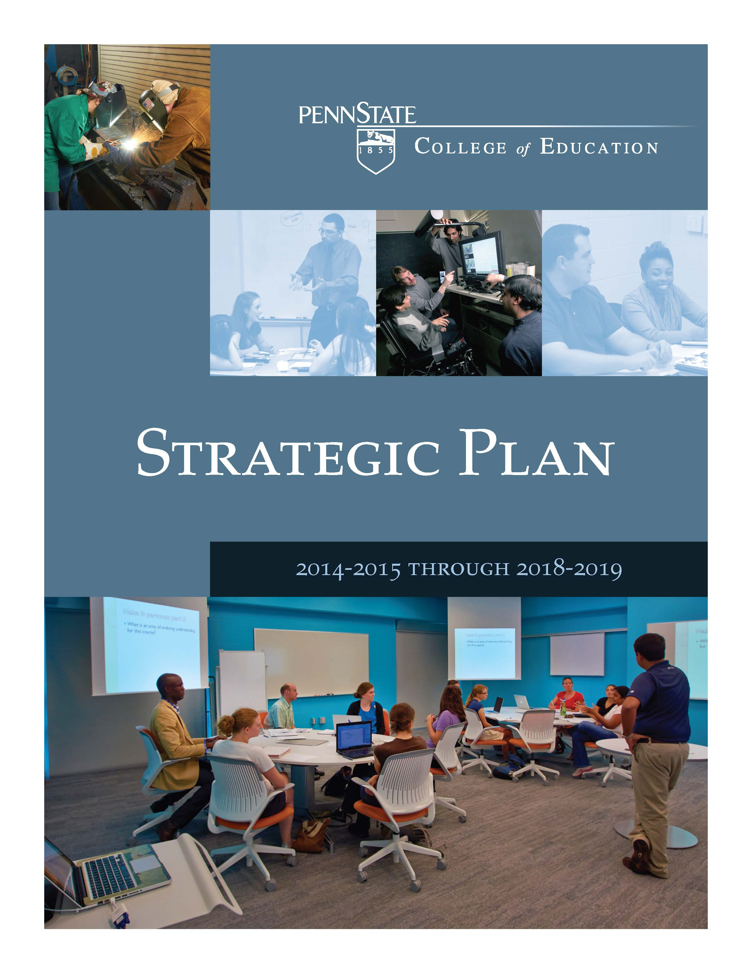

April 14, 2015

# College of Education

Penn State University

Strategic Plan 2014-2015 through 2018-2019

Summary Version

## I. Overview and Executive Summary

We welcome this opportunity to describe the strategic plan we have developed for the College of Education. While we have made good progress toward articulating our priorities and our sense of the most promising opportunities for the College during the next five years, we see our plan as a work in progress that will need to be adjusted as time passes and as the University formulates its priorities for the future. We are in a particularly significant planning period for the University given the arrival of new leadership in key administrative leadership positions. We have noted the Provost’s interest in “tweaking” the past Penn State strategic planning process to make it more interactive across levels. Indeed, we have employed a similar approach to our planning effort within the College and have characterized it as a hybrid approach that takes advantage of the interest and energy within our Departments and Programs while not losing sight of the cross-cutting themes that are important to us as a College. We seek to be more than the sum of our parts and believe there is an important role for the College to play in making connections across our Departments and Programs. We see the central University playing a similar role as it seeks to build connections across individual Colleges and Campuses.

The College of Education is deeply committed to the Penn State diversity agenda as embodied in the Framework to Foster Diversity. We recognize the importance of infusing diversity planning into the larger strategic planning effort of the University, and we have responded by addressing diversity issues throughout the plan as well as by preserving a section of the plan where we explicitly address diversity issues surrounding the seven challenges in the Framework. Please review the complete plan at: <http://www.ed.psu.edu/internal/strategic-plan-2014> to see this section.

### Planning Process

We began thinking seriously about our next strategic plan during the spring of 2013. The first step was to take stock of our previous plan and to assess what we achieved and what remained to be achieved. One of the most concrete and visible achievements from our previous strategic plan is the creation of the Krause Innovation Studio. The idea for this studio began in our Strategic Plan for 2008-09 through 2012-13. The faculty took advantage of the planning effort to refine ideas for an innovative teaching, learning, and research space that would position us well for the future. At the time, funding was not available, but the ideas proved to be powerful and made it possible for us to secure a very generous gift from Gay and Bill Krause. The Krause Innovation Studio is now a reality, and we are using this progress as the basis for going even further in this plan with an innovation theme.

We next convened a retreat for a broadly representative group of faculty and staff that was led in May 2013 by Mike Dooris, the Director of Penn State’s Office of Planning and Institutional Assessment at that time. The retreat was designed to help us frame cross-cutting themes we wished to address as a College. We subsequently worked with the College’s elected Faculty Council to refine and finalize the items on the list.

We created a Strategic Planning Steering Committee to guide the development of various parts of the plan. The Steering Committee is broadly representative of the College and includes faculty members, staff members, a student, and the President of our Alumni Society Board of Directors.[1]

The Steering Committee helped refine the list of cross-cutting themes and decided to form a set of Focus Groups, one for each theme, to help the College delve more deeply into each of the identified cross-cutting themes. The Steering Committee also played a central role in identifying leadership for each of the Focus Groups we formed.

We ultimately identified the following eight cross-cutting themes for the College to explore:

1. Advancing Effective Innovation in Teaching and Learning
2. Embracing the Richness of Diversity
3. Improving Sustainability
4. Reducing Disparities in Opportunities and Performance
5. Enhancing Learning in Online Environments
6. Creating and Marketing Intellectual Property and Services
7. Strengthening and Creating Partnerships
8. Enhancing Contributions to General Education

It has been the Steering Committee’s responsibility to pull together the ideas that surfaced from within the Focus Group efforts, as well as from within the Department and other budget unit efforts, in addition to those coming to us from our Alumni Society Board of Directors. The Steering Committee has also endeavored to be attentive to the ideas introduced by the President and the Executive Vice President and Provost as the planning process unfolded.

This document is a summary version of the complete plan which was submitted in July 2014. The complete plan can be found at: <http://www.ed.psu.edu/internal/strategic-plan-2014>.

## II. Mission, Values, and Vision for the Future

### Mission

The mission of the College of Education at Penn State is to deepen and extend knowledge about the formation and utilization of human capabilities.

Our efforts to deepen knowledge lie at the heart of our lives as scholars who develop and conduct dynamic programs of research and development. Our efforts to extend knowledge speak to our fundamental commitments to high quality teaching and its improvement. We are well known for our focus on the formation and expansion of human capabilities through the preparation of teachers, instructional designers, administrators, counselors, human service professionals, and psychologists. We are also interested in improving how society makes the best possible use of what people learn, and this prompts efforts to improve the utilization of human capabilities through the provision of mental health services, including counseling, in schools and communities and through the study of education’s contributions to social and economic development. These efforts include the study and improvement of domestic as well as international education public policy development and implementation.

We work in formal schooling settings as well as in less formal educational settings such as the workplace where on-the-job training occurs. Our interests in less formal learning spaces also extend to the home, community, and cultural organizations such as museums, arboretums, and cultural centers.

We are interested in learners at widely varying age levels, from young children to senior adults. We also work with widely varying types of learners, including learners with special needs of various kinds as well as those who are gifted in some way.

We are connected to a broad range of content areas including the physical and biological sciences, mathematics, the humanities, and the social sciences. We also study educational endeavors from organizational perspectives as we seek to improve the ability of schools and related organizations to function efficiently and effectively.

We employ a wide variety of research and methodological tools as we pursue our scholarship. The College includes faculty members with advanced quantitative analytical skills as well as faculty members who excel with qualitative research strategies. The faculty’s research portfolio includes studies based on randomized controlled trials, secondary data analysis, single subject designs, and ethnographies, to name just a few research strategies. The disciplinary perspectives within the College also vary widely, ranging from a focus on the field of education to discipline based perspectives rooted in psychology, sociology, linguistics, design, economics, history, law, philosophy, anthropology, mathematics, and the physical as well as biological sciences, to name some examples.

Finally, we seek strong connections between research and practice. We conceive of ourselves as a professional college with deep commitments to understanding and solving problems of practice in the field.

### Values

We are deeply committed to the belief that all human beings can learn and that we have a responsibility as a College for alleviating whatever impediments or barriers might interfere with a particular learner’s ability to make progress. These impediments come in many forms and include both physical and cognitive disabilities that might exist as well as circumstances that may have placed a learner at risk for failure. This drive to enhance the success of all learners, particularly those who through no fault of their own face an impediment to their success, is a powerful motivator for us as a College.

We also affirm a commitment to the reduction of disparities in the distribution of educational outcomes and—by extension—social and economic consequences. While we recognize that parallel improvements across groups constitute progress, we also seek a narrowing of achievement differences across groups. This commitment stimulates a special emphasis on reducing impediments for those at the lower end of the achievement distribution.

We also recognize the significant roles culture, cultural practices, and cultural knowledge all play in the expansion and utilization of human capabilities. We believe we have a responsibility as educators to develop and provide culturally relevant and responsive educational opportunities.

We place a high value on cooperation and recognize that solutions to the most pressing problems facing the field of education and larger society cross disciplinary boundaries and presume an ability to work collaboratively and form meaningful partnerships. We recognize that diverse points of view need to be present in teaching, research, and service and that strong and enduring partnerships can help to institutionalize our ability to harness the power of diversity.

Finally, we have a deep commitment to the roles inquiry and evidence need to play in the further development and improvement of the field of education and society. We advocate for the support of high-quality research and encourage our faculty members to conduct policy-relevant research and to share the resulting evidence with the relevant decision makers. We seek to take full advantage of the results of inquiry, both in our efforts to prepare the next generation of educators in their many roles, and in our efforts to communicate findings to the larger society.

### Vision for the Future

For the future, we see our faculty, staff, students, and alumni excelling in a number of key areas. Here we provide an annotated list of the areas where we have set explicit goals.

#### The Learning Sciences

There is growing interest in strengthening links between efforts to design teaching and learning experiences and fields like cognitive psychology and computer science. The term “learning sciences” has emerged in the field to describe the resulting scholarship. Within the College of Education, work in this area can be found in our mathematics and science education emphasis areas as well as within our Educational Psychology and Learning, Design, and Technology graduate programs. We are adding faculty strength in this area and see important applications in K-12 education as well as in more informal settings, including the workplace. We are also exploring a possible collaboration with the Penn State Institute for CyberScience where the goal is to strengthen our ability to harness the power of “big data” and advanced computing capabilities to tailor teaching and learning efforts to better meet the personalized needs and capabilities of learners of all ages. Professor Richard Duschl, the Waterbury Chaired Professor in Curriculum and Instruction, has agreed to lead a task force that will help guide our efforts in the Learning Sciences. We see strong connections between this effort and Penn State’s emerging commitments to a) transforming education and access and b) leveraging our digital access.

#### Science, Technology, Engineering, and Mathematics (STEM) Education

We have a longstanding commitment to STEM education and have been working to maintain and enhance strong faculty groups in mathematics education and science education. We are also seeking opportunities to connect elements of STEM education in our career and technical education programs.

Our continued interest in STEM education is timely given the increasing attention being devoted to what have become known as coding skills. The resurgence of attention to coding (which was very popular in the 1980s) resonates with increased societal attention to STEM education. Coding requires problem solving skills with an emphasis on making use of logic and structure. These are key skills that develop out of the study of mathematics and science. Our commitment to the effective use of technology in the context of mathematics and science education with the concomitant emphasis on programming skills will position us well to meet growing demands for coding skills.

#### Early Childhood Education and Child Protection and Well-Being

The Child Care Task Force report for Penn State, with its call for additional tenure-line faculty positions in early childhood education, has stimulated interest within the College in strengthening our early childhood education programs. The close proximity of the Hort Woods Child Care facility along with the Pennsylvania Department of Education’s decision to offer a separate certification at the PreK-4 level have stimulated additional interest. This is a highly productive area of research, and we look forward to expanding efforts in this area of the field. Collaboration possibilities abound as there are many places in the larger University where faculty members pursue closely related interests.

The Department of Curriculum and Instruction has proposed the creation of a new laboratory space with an early childhood education focus. Such a space would exist in parallel with the existing laboratory spaces the College supports in the areas of mathematics education, science education, language and literacy education, and social studies education.

We are committed to the protection and well-being of children and endeavor to ensure that our graduates are prepared to detect abuse and to work effectively with those who have experienced maltreatment. Several parts of the College are active participants in the Penn State Network for Child Protection and Well-being, and we are currently searching to appoint a co-funded tenure line faculty member who will become an important part of Penn State’s investment in this area of research and development.

#### Language Acquisition and Utilization

We recognize the increasingly important role of language acquisition as populations become more linguistically diverse. We have a responsibility to prepare future educators for the increasingly diverse clienteles they will be working with over the course of their careers. We are particularly sensitive to the needs of English language learners.

#### Diverse Literacies

Our Curriculum and Instruction Department has assigned a high priority to what it calls “diverse literacies.” The Department includes intercultural competence, global citizenship, and environmental literacy under this umbrella. The Department also recognizes important connections to emerging social media technology. We are interested in thinking through the implications of social media for teaching and learning throughout educational systems.

#### Prevention and Intervention Sciences

Our Department of Educational Psychology, Counseling, and Special Education has singled out prevention and intervention sciences as an increasingly important organizing theme. The Department is particularly concerned with finding ways to be helpful to students of all ages who are facing physical, cognitive, or emotional impediments as they seek to develop and utilize human capabilities. We see elements of our enduring commitment to Disability Studies fitting under this heading.

#### Education and Civil Rights

Our recent faculty hires include a group of individuals located in several Departments and Programs with interests and expertise in the intersection between education and civil rights. These are very timely appointments given the lively debates taking place nationally and internationally regarding policies like affirmative action. The College hosted a major conference focused on Education and Civil Rights during the summer of 2014 that involved collaborations across many parts of Penn State. We plan to strengthen these efforts in the future.

#### Organizational Studies

The College maintains a longstanding interest in the design, function, and evolution of organizations, including but not limited to educational organizations, to achieve societal goals. Our Educational Leadership Program is interested in K-12 schooling organizations while our Higher Education Program and the Center for the Study of Higher Education are directly interested in the design, function, and evolution of post-secondary organizations. Our Workforce Education and Development Program deals more broadly with the function and effectiveness of the workplace in corporate and nonprofit settings. We recently launched a new M.P.S. program in Organizational Development and Change through the World Campus. An interest in organizational studies will continue to be a priority for the College in the foreseeable future.

## III. Specific Strategies to Achieve the Vision

Here we enumerate the strategies we have identified to help us respond to achieve the goals we have identified.

#### Stepped Up Strategically Selected World Campus Offerings

We have been working closely with our colleagues in the World Campus to rejuvenate some long standing Education offerings on the World Campus and to develop new programs of study. No fewer than seven programs are in the process of being developed or redesigned. We expect our involvement with the World Campus to expand significantly over the next five to ten years.

#### Stepped Up Commitment to Strategic Partnerships

We have increasingly realized that we can accomplish more when we work together with entities within as well as outside of Penn State. We seek to build upon the already impressive number of partnerships we have been involved with over the years.

#### Stepped Up Student Recruitment and Retention Efforts

We have established a Student Recruitment Task Force to look carefully at short term as well as longer term steps we should take to make the College of Education more visible to students looking for strong baccalaureate programs in education. At the graduate level, the new model for student recruitment and retention along with curriculum development and coordination will lead to more coherent and deliberate efforts to recruit and retain the top graduate students to the programs at Penn State.

We are making it possible for those preparing to be teachers to develop a range of specialized skills in addition to the core set of skills they develop in pursuit of Pennsylvania certification. The resulting “endorsements” we will offer will be designed to enhance our graduates’ attractiveness to prospective employers. We are in the process of developing the following “endorsement” options for our students: teaching students with special needs; teaching in online K-12 environments; teaching English language learners; teaching with the expertise of a Reading Specialist; and teaching with expertise about diversity and multicultural dimensions of education.

#### Stepped Up Uses of Technology and Other Forms of Innovation

Thanks to the creation of the Krause Innovation Studio, the College is well-positioned to continue building on an innovation in education theme. This commitment to innovation also tracks well with the emerging University priority for Transforming Education and Access. We are committed to a transformation agenda that encompasses resident as well as online education environments. We are similarly committed to the idea that the purpose of technology and innovation is to improve teaching and learning. We are not interested in technological and other forms of innovation for their own sake.

#### Stepped Up Efforts to Stay Connected with Graduates

Our national accrediting agency, the Council for the Accreditation of Educator Preparation (CAEP), has established demanding standards for following graduates and ascertaining their impact on their students’ learning. Following our graduates is not a new activity for the College, but it is clear that we will need to pursue these efforts more actively in the future in order to maintain accreditation. We also have our own interests in following our graduates’ subsequent professional experiences. Our Alumni Society Board of Directors is actively involved in assisting the College in efforts to follow-up and stay in touch with our graduates. The advent of Facebook, Linkedin, and evolving social media are providing new ways of staying in touch with graduates. The College is actively developing these networks. As of June 24, 2014, the College of Education was reaching 4,195 friends on Facebook and 1,423 followers on Twitter.

#### Stepped Up Contributions to General Education

Penn State is in the midst of a serious effort to re-think and re-design its General Education requirements. Being a professional college, the College of Education historically has not played an important role in delivering General Education courses. However, some of the new ideas being discussed suggest that a college of education could and perhaps should play a more central role. We are open to this possibility.

#### Stepped Up Web Presence

Finally, we are increasingly aware of the fact that our website is our doorstep to the outside world. The recent redesign of our website was conducted with this realization in mind and involved extensive consultation with the relevant stake holders. We expect to continue investing in the College’s web presence over the next five years and beyond.

## IV. Immediate Next Steps

We close with thanks to everyone who contributed to the creation of this plan along with a list of the key next steps we see ourselves taking. We also reiterate our firm belief that we are engaged in an ongoing planning process and that our plan will need to be refined as we learn more and external conditions evolve.

What follows is a list of key next steps to take as we seek to implement the letter as well as the spirit of our strategic plan for 2014-2015 through 2018-2019.

* Create the Student Recruitment and Retention Task Force
* Launch New Efforts to Follow Graduates and to Monitor Impact
* Strengthen the Work of the Assessment Committee
* Continue to Implement the Penn State Human Resource Transformation Pilot Project
* Implement the Refined Model for Student Recruitment and Retention and Curriculum Development and Coordination
* Implement a New Staffing Model to Support Curriculum and Website Development
* Enhance World Campus Offerings, including a possible undergraduate offering in RHS
* Develop and Support Strategic Partnerships
* Strengthen the Uses of Technology and Other Forms of Innovation
* Create the Identified Endorsements in Teacher Education
* Increase the College’s Role within General Education
* Continue to Refine and Strengthen the College’s Web Presence
* Strengthen Diversity Enhancing Efforts that Meet the Best Practices Standard
* Conduct an Inventory of Courses with Diversity Content
* Conduct an Inventory of Courses with Sustainability Content
* Create a Standing Sustainability Committee
* Continue to Invest in the Learning Sciences with a Possible Collaboration with the Penn State Institute for CyberScience
* Reassess the Possibility of Creating an Instructional Design Support Organization in light of the Focus Group’s Recommendation
* Continue to Explore the Entrepreneurial Endeavors Focused on Curriculum Products and Program Evaluation Services
* Continue to Enhance Research Infrastructure Support
* Create an Early Childhood Education Laboratory

1. The following individuals served as members of the Strategic Planning Steering Committee: Patricia Best, William Hartman, Brandon Hunt, Peter Licona, Gwen Lloyd, David Monk, Priya Sharma, Jeanine Staples, Sue Tighe, and Suzanne Wayne.