Unit Strategic Plan: Graduate School
  - 2014/2015 through 2018/2019
A more detailed version of this plan can be found at:
http://www.gradschool.psu.edu/about-us/stratplanandtfrpts/

CONDENSED

STRATEGIC PLAN

2014–15 through 2018–19

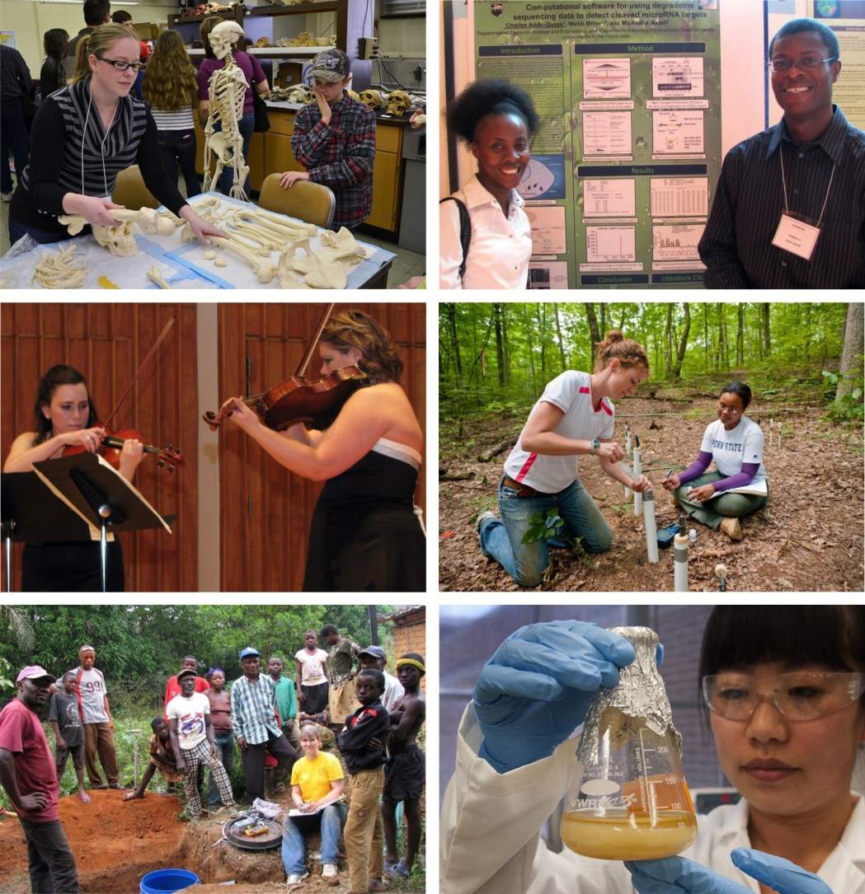

Vision
Penn State will be one of the nation's preeminent universities in graduate education and research, and a "first choice" university for graduate students.

Mission
The mission of the Graduate School is to promote the highest quality graduate education that prepares interdisciplinary leaders who advance knowledge and understanding, drive innovation, and contribute to the resolution of complex national and global problems to meet societal needs.

Values
- PENN STATE COMMUNITY: The Penn State graduate education community is one of scholars who are creative, generate new knowledge through rigorous inquiry and critical analysis of evidence, and are continually open to new information in advancing understanding within our disciplines and our local and global communities.

- RESPECT: We honor the dignity of each person and treat each individual accordingly, engage in civil discourse, and foster an inclusive community. As scholars, we seek the broadest diversity of thinking, exchange ideas informed by evidence, and avoid assumption, preconception, and subjectivity.

- RESPONSIBILITY: We meet our obligations and hold ourselves accountable for our decisions, our actions, and their consequences.

- INTEGRITY: As scholars, we are constantly open to changing or rejecting our hypotheses based upon new evidence, in the interest of advancing knowledge. Although our decisions are informed by evidence, they are guided by the highest ethical standards, assuring that our behavior reflects our values.

- DISCOVERY: We seek and create new knowledge and understanding, and foster creativity and innovation, for the benefit of our communities, society, and the environment.

- EXCELLENCE: We strive to give and do our best in all our endeavors.

SUMMARY
This Summary outlines the priority goals of the Graduate School. Details regarding these goals and the strategies for achieving them, as well as the broader thematic goals of the University, may be found in the full report of the Graduate School’s 2014/15 to 2018/19 Strategic Plan at http://www.gradschool.psu.edu/about-us/stratplanandtfrpts/.
The Graduate School at Penn State is the enterprise-wide organization responsible for overseeing the admission, matriculation, and graduation of all graduate students, excluding professional students in the College of Medicine and The Dickinson School of Law, and is the home for several Intercollege Graduate Degree Programs (IGDPs). It provides administrative oversight and support to the University’s Graduate Council, the faculty governing body for academic policies related to graduate education, and sets administrative policies and processes to support these.
In addition to its administrative functions, the Graduate School is the central unit that promotes best practices and provides professional development for graduate students to augment the efforts of graduate programs and colleges. The Graduate School also serves as the body that reviews the quality of graduate degree programs; raises awareness of and advances, through college administrators for graduate education, national thinking on graduate education; and helps to align strategies of interest with individual colleges.
As of Spring 2014, Penn State has more than 163 graduate degree programs with 105 doctoral programs, 110 academic master’s degree (Master of Arts [M.A.] and Master of Science [M.S.]) programs, and 81 professional master’s degree programs.
This plan frames the status of graduate education at Penn State and lays out goals that are (1) required to support the infrastructure that allows the management of programs and student needs and (2) intended to drive the quality of graduate education throughout the institution. For relevant data that contributed to formulation of these goals, and that were the basis for the analysis of the status of graduate education at Penn State summarized below, see the Graduate Student Profile, pages 13-34 of the full Penn State Graduate School Strategic Plan.

Status of Graduate Education

  - Resident master’s degree and nondegree graduate enrollments have declined steadily for almost a decade, primarily at non-University Park locations, and with all of the loss being PA students.

  - World Campus graduate enrollment growth of primarily non-PA students has compensated for Resident declines, and constituted more than a third of total enrollments in 2013, but new growth has essentially plateaued since 2011.

  - Penn State has lost PA market share and should market its online master’s degree and postbaccalaureate/graduate credit certificate programs more heavily within PA.

  - The percentage of international students has increased to almost a third of Resident enrollments, with the primary source countries remaining China, India, and Korea. Other global regions that have been less cultivated (e.g., South America) remain opportunities.

  - International graduate enrollments in World Campus have remained negligible and present an opportunity for future marketing and enrollment growth, and, importantly, to add diversity to Penn State’s online graduate programs.

  - Ethnic/racial diversity of Resident enrollments has changed negligibly over almost a decade, with percentages of underrepresented minority (URM) students abysmally low, but an increasingly diverse population is enrolled online.

  - A male majority enrolled online suggests that graduate programs that attract a greater female applicant pool (e.g., health care; education) may advance World Campus enrollment growth.

  - Students are seeking master’s degrees online soon after completing their baccalaureate, so that “direct” marketing to Penn State undergraduates may be an opportunity.

  - Penn State’s doctoral programs are more competitive, but fewer offers are being extended in a difficult funding environment, so that new doctoral accepts are declining and a cause for concern.

  - Declining new doctoral admits predict a continuing trend of fewer doctoral degrees conferred that likely will continue in the absence of alternative funding, particularly in fields tied to extramural support (e.g., STEM fields).

  - World Campus-delivered master’s degree programs appear less selective than resident master’s degree programs, although this may reflect prescreening that makes assessment based upon selectivity and yield problematic.

  - World Campus-delivered professional master’s degree programs continue to offer opportunities for growth, with degrees conferred increased almost 1,000-fold from one degree awarded in 2005, and predicted to continue with new accepts increased in 2012 and 2013.

Priority Goals for Graduate Education

Advancing Technologies for Support of Graduate Education

Support of implementation of the new student information system (SIS), LionPATH.

The replacement of Penn State’s legacy student information system is a critical priority and will require significant resources from the Graduate School over the next three years. The software implementation process will include the review and potential redesign of all student-related business processes throughout the university. The Graduate School will have the opportunity to provide new services that could not be supported in the past, to automate processes that currently are manual, and to change inefficient or less efficient processes. The goal of the process review and redesign is to configure the software with little-to-no customization of the base PeopleSoft product (Campus Solutions). Because undergraduate and graduate student processes frequently differ, the Graduate School staff will be diligent in each review, mainstreaming when possible and making the best possible case when differentiation is required.

      - Participate in the LionPATH project implementation team, steering committee, and executive committee;

      - Review and redesign business processes; create online workflow systems for high-volume processes and forms;

      - Test systems and provide extensive training for all staff; maintain parallel systems and processes through full implementation;

      - Reprogram graduate-specific bolt-on systems to interface with the new SIS; and

      - Train graduate program staff regarding new graduate-specific processes and functionalities in the new system.

Centralizing and digitizing transcripts

In an effort to reduce workloads for graduate program offices, the Graduate School will work towards centralizing the processing of incoming transcripts and, where possible, manage them digitally. Before an applicant can be formally offered admission to a Penn State graduate program, he/she must submit official transcript(s) from institutions previously attended, and Graduate Enrollment Services (GES) Coordinators verify eligibility based upon the institution and credential, and the authenticity of the transcript. This is especially difficult given the number of transcripts coming from international institutions. Business process redesign will be implemented to receive and process transcripts in a more efficient manner, especially with respect to receipt of transcripts in digital format from institutions that utilize electronic transcript services.

      - Strategically reevaluate and redesign business process flow to reduce volume of hardcopy transcripts processed;
      - Redirect applicants to upload transcripts to their application portfolio for review by programs;
      - Require official transcripts to be sent to Graduate Enrollment Services (GES) only from applicants accepting offers of admission;
      - Eliminate processing of transcripts by graduate program staff; and
      - Automate processing of domestic transcripts available in digital format by GES coordinators.

Constituent Relationship Management (CRM) system

Graduate students and units that support them could benefit greatly by leveraging communication technology that is becoming commonplace in many other industry sectors. Constituent Relationship Management (CRM) systems help organizations provide excellent service by managing incoming and outgoing communications, as well as storing pre-defined data fields to better serve the interests of clientele, ultimately resulting in greater productivity for the organization due to increased efficiency and a higher capacity.

The graduate admissions process is not managed solely by the Graduate School. Graduate programs select applicants to whom they wish to offer admission, while GES coordinators verify eligibility for those prospects and confirm to the respective applicant his/her admission to the Graduate School. Today there is a custom-built system, the Graduate Admissions Decision System (GRADS) that aids in the sharing of application information between the Graduate School and graduate program offices. This system is limited in what can be entered, and does not, for example, capture and store communications with prospects. In addition, not all of the capabilities of the system have been adopted by every program office. Given the limitations, it is difficult for the Graduate School to enforce 100% utilization. With a robust CRM system, both graduate programs and GES would have real-time information about applicants. Consistent messaging could be developed and delivered to prospective students in a timely manner.

It will be necessary to integrate the CRM with the student information system (SIS) to maintain data integrity. The student information system will be the system of record for all current students, and there is no reason to duplicate effort by re-entering that same information into a CRM system. With appropriate integration, changes made to the SIS can be seen in both systems without additional effort.

      - Explore enterprise-level CRM system to improve efficiency and enhance constituent experience;
      - Establish working team to develop strategy around CRM;
      - Define system requirements;
      - Determine feasibility and funding model;
      - Coordinate vendor demonstrations; and
      - Implement across all Graduate School, academic administrative, and graduate program offices.

Redesign/reorganization of the Graduate School’s website and the Graduate Application for accessibility and usability

In conjunction with experts in this area from the World Campus, the Graduate School has initiated an assessment of the Graduate Application design and usability utilizing web analytics and user testing, and will be implementing a redesign to enhance the user experience. Over the upcoming five-year Strategic Planning period, the Graduate School staff will use search engine optimization (SEO) to increase traffic to the application; improve the visual design and usability of the application to increase the number of completed applications; and improve the branding of the Graduate School web pages and Graduate Application.

      - Assess Graduate Application design and usability using web analytics and user testing;
      - Redesign website and Application to enhance user experience;
      - Utilize search engine optimization (SEO) to increase traffic to the Application;
      - Improve visual design and usability of the Application to increase the number of completed applications; and
      - Improve branding of Graduate School web pages and the Graduate Application.

Advancing Strategies in Support of Graduate Education Quality

Graduate Program Quality and Student-Centered Metrics

Is Penn State positioned to achieve/maintain excellence?

The quality of doctoral programs represents the lifeblood of a research university. In 2000-01 and again in 2003-04, the Graduate School initiated internal review of all graduate programs in which we collected data that allowed us to review the size of programs, time to degree, as well as indicators of student quality through measures including GPA and GRE scores at the time students are recruited. We have not conducted a review for a number of years because of the time and effort that was demanded in collecting and submitting data from 2006 through 2008 for the majority of our Ph.D. programs reviewed by the National Research Council (NRC) as part of their periodic survey that was released in Fall of 2010, and subsequently, the University-wide Core Council review of all academic and administrative programs in 2011. The Graduate School was represented on both the University Park Academic Review Coordinating Committee (UPARCC) and Core Council for this purpose.

What we have learned from prior reviews is that programs are often not aware of objective measures of program quality for their own units. The two largest problems we see are that many of our programs are rather small, and the level of diversity within resident programs is exceedingly low, with no improvement in almost a decade. The challenge to program faculty is determining how to deliver a quality program when the enrollment and level of diversity are relatively low. In the case of small programs, it often becomes difficult to offer all the courses students expect when they enroll, and student-student interactions are below a critical threshold and not informed by diversity of student experience and perspective. Several reasons exist why student numbers may be low: insufficient resources to support students; multiple graduate programs that overlap in content or context, thus creating internal competition for student numbers; a weaker overall program based upon faculty reputation. The latter problem is beyond the scope of the Graduate School, so we will focus on the first two areas for which we will suggest opportunities.

Recruitment of a more diverse graduate student body has been a chronic problem and one that requires investment and commitment by the entire faculty and leadership of programs and colleges, in partnership with the Graduate School. In this section are efforts towards greater transparency in providing metrics that will allow programs to monitor progress towards program quality goals, including diversity, and plans to more directly tie financial resources allocated to colleges for graduate recruitment and program improvement to specific metrics that include increasing the number of URM Ph.D. enrollments.

Conduct regular graduate program reviews

      - Provide graduate programs and colleges with program quality metrics on a continuous basis to enable assessment of trends and impact of strategies to improve;
        - Create program review Dashboards with metrics relevant to program quality over an annually refreshed 10-year window.
        - Create Placement Portal with placement data collected initially for doctoral programs and eventually master’s degree programs.
      - Review program metrics with colleges on a three-year cycle; and
      - Allocate Graduate School resources to colleges for graduate education tied to indicators of program quality.

Improve graduate student support.
      - Advance strategies for colleges to raise minimum stipend grades that fall below the cost-of-living for the campus location and extend multi-year offers of support for the median time-to-degree (TTD) for each Ph.D. field; and

      - Offer competitive stipends appropriate to the field and (preferentially) fellowship support to enable the most nationally competitive prospective students to be recruited and increase yields of such students.

        - College-Level Strategies
          - Where appropriate, strategically downsize the number of GA slots and reallocate resources to raise stipend grades and provide multi-year packages of support.
          - Elevate graduate support as a development priority for the college.
          - Where a quality program that meets a societal need can be provided, and demand for the program exists, strategically expand professional master’s degree and postbaccalaureate/graduate credit certificate programs that can generate net revenue, including reinvestment in resident degree programs central to the college mission.
        - Graduate School Strategies
          - Expand and enhance the University Graduate Fellowships (UGF) program.
          - Continue and expand the Distinguished Graduate Fellowship (DGF) incentive program.
          - Expand and enhance college-specific National Science Foundation Graduate Research Fellowship Program (NSF-GRFP) Incentive Awards.
          - Sponsor Graduate School workshops for NSF-GRFP application development.
          - Leverage resources to increase external support for graduate education through faculty incentive programs.
            - Grant-in-Aid Incentive Program.
            - Pre-Doctoral Training Grant Development Incentive Award.

Promoting and Facilitating Interdisciplinary Graduate Education.

The value of interdisciplinary approaches to solving complex, societal problems has long been recognized, and graduate education at research universities must continue to evolve towards increasingly interdisciplinary models to support such approaches. As stated in the (March 21, 2008) Report of the Task Force on Interdisciplinary Graduate Education (http://forms.gradsch.psu.edu/memos/tfrptIdGrEdForACGE.pdf), “Collaborative, interdisciplinary graduate education must be an institutional priority in order to meet societal needs, prospective student interests, and demand, and to ensure that Penn State remains competitive in securing extramural research funding into the future.” The Task Force identified desirable characteristics of interdisciplinary programs to include the following:

- Address complex and novel/important problems
- Create faculty/department/college synergy and collaboration
- Build on institutional strengths
- Attract high-quality students
- Provide credit to faculty (including a formal mechanism for evaluative feedback during the P&T process)
- Engage in continuous self-study of sustainability and viability
- Provide students with an avenue to satisfy diversity of professional career interests
- Provide value-added scholarship for the student
- Allow for flexibility in terms of multiple sources of student entry and exit/placement

The Task Force also looked at interdisciplinary models from a number of benchmark institutions and concluded that one model already employed by Penn State seemed to provide the greatest opportunity to enhance interdisciplinarity in graduate education, while being the least disruptive to the resource base of the institution. That model is the Dual-Title Degree. The following is a quote from the Task Force report that captures the value of this approach:

“In contrast to the stand-alone graduate program (departmental or intercollege), the dual-title degree is a unique model that not only allows the student to receive value-added training in another field that is reflected in specialized coursework, but ensures the additional field is integrated into the research problem and thesis/dissertation to provide for truly interdisciplinary training. Because students must be enrolled in a primary program before admission into a dual-title field, they are anchored to an academic unit that generally provides physical and administrative assets (e.g., office space, computer access, staff assistance) and financial support, but ultimately pursue both degrees simultaneously and in a truly integrated fashion. The student receives a single diploma titled in both fields of study, and is acknowledged to have the degree in both areas. Importantly, unit leaders and primary program heads do not feel the dual-title program competes with departmental programs, and both are equally and fully credited for the training they provide to the student. For these reasons, the dual title degree is viewed as an excellent approach that is underutilized and not well recognized.”

    - Encourage the development of dual-title graduate degree programs;
    - Reduce the development of new, stand-alone intercollege graduate degree programs and consolidate overlapping, small programs wherever possible;
    - Promote the conversion of existing intercollege, graduate degree programs (IGDPs) to dual-title graduate degree programs where appropriate;
    - Earmark resources for recruitment and retention of excellent graduate students for intercollege, interdisciplinary programs that demonstrate quality characteristics; and
    - Assure that the new student information system (Project LionPATH) captures information related to each doctoral student’s adviser, and that enrollment and degree conferred for each intercollege student are appropriately credited to the advisor’s unit in official reporting.

Increasing Diversity of the Resident Graduate Student Population

One of the highest-priority goals for the Graduate School is to increase the diversity of the resident graduate student body, particularly with respect to URM students enrolled in doctoral programs. The section below outlines the Graduate School’s strategies over the next five years in this respect.

In order to assure that all of the questions related to the seven Challenges presented in the Framework to Foster Diversity at Penn State 2010–2015 have been addressed fully, these are detailed separately in the full Strategic Plan (Appendix B: III. Diversity Planning (http://www.gradschool.psu.edu/about-us/stratplanandtfrpts/).

    - Support the expansion and coordination of the Fall STEM Open House, a new initiative for recruitment of URM students in STEM fields.
    - Develop relationships with small liberal arts colleges throughout Pennsylvania, in order to seek out talented URM undergraduate students who are interested in enrolling in graduate school, with emphasis on STEM disciplines.
    - Collaborate with the Director of the Millennium Scholars Program in the Eberly College of Science and the College of Engineering to provide opportunities for the Millennium Scholars to meet and be mentored by current URM STEM graduate students, in order to create a new pipeline of URM STEM undergraduates to enter our graduate programs.
    - Explore possible strategies to recruit and retain competitive URM students currently enrolled in World Campus-delivered professional master’s degree programs for doctoral study.
    - Begin to collect additional data from the Graduate Application that provides information on applicants’ geographic background and involvement in federally funded programs designed to increase the number of first-generation and low-income students within higher education, to enable the Graduate School to target recruitment efforts more effectively and determine gaps with respect to the recruitment of diverse populations of applicants.
    - Increase use of social media to aid in the recruitment of a more diverse graduate student population and to assist with retention of current students by disseminating information regarding the Graduate School’s professional development activities more effectively.
    - Enhance the success of the Summer Research Opportunities Program (SROP) in recruiting students from underserved groups to graduate study at Penn State. Through prudent selection of SROP students, strive to entice 75% of these individuals to apply to Penn State for graduate school, with the goal of 50% of the SROP student pool eventually enrolling in graduate programs at Penn State.
    - More aggressively recruit students from McNair programs throughout the United States to apply for graduate study at Penn State, and track the application and enrollment of these students. The goal of this effort will be to enroll 20–25 McNair alums per year.

