Unit Strategic Plan: Penn State Hazleton
  - 2014/2015 through 2018/2019

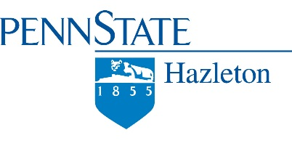
2014 - 2019
Strategic Plan
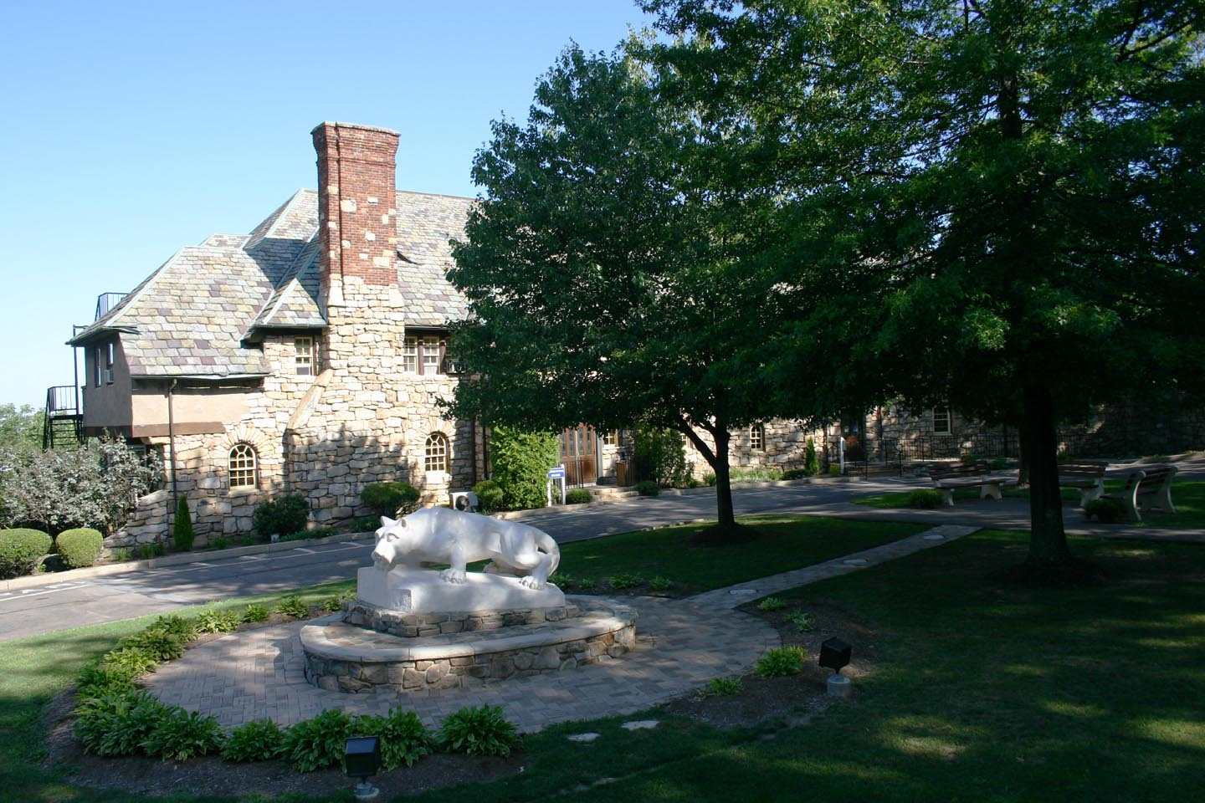

Vision and Mission Statements for
Penn State Hazleton

The Strategic Planning Council met to reflect on and revise the current vision and mission for the Penn State Hazleton campus. Following a long discussion, the following statements emerged:
Vision - Penn State Hazleton will be a leading educational institution that advances knowledge, creativity, and opportunity in a dynamic campus environment, supporting academic and research excellence, innovative programming and pedagogy, and community outreach.
Mission – Penn State Hazleton upholds the highest standards in teaching and learning, while being a gateway to the rest of Penn State University. The campus employs student-centered approaches to extend access, fosters engaged scholarship, and embraces diversity. Penn State Hazleton extends the land grant mission of the University which promotes teaching, research and community service.

2014 - 2019 Strategic Planning Themes
1) Extend the 21st Century Land Grant Mission
2) Advance Educational Innovation
3) Promote Ethics, Values & Behaviors
4) Foster Diversity
5) Enhance Sustainability
6) Invest in Technological Changes
7) Plan Budgets Purposefully
8) Expand Infrastructure

1) Extend the 21st Century Land Grant Mission
Access, affordability, collaboration with campuses, connections with K-12, equity, global outreach, development, alumni, community outreach
- Increase overall campus enrollment to at least 1,300 students by 2019, with the eventual goal of 1500, by expanding degree and certificate offerings, adding dual-enrollment programs, and continuing to form articulation agreements with local community colleges.

- Expand portfolio to 15+ Baccalaureate degrees singly and in collaboration with sister campuses. [Target #: 15; Academic Affairs – Spring, 2019] [Target #: indicates number relative to goal; next is area(s) of responsibility; and date is semester of completion]
- Collaborate and create solid articulation agreements with area community colleges to strengthen relationships between the institutions, and increase enrollment. [Target#: 3; Academic Affairs and Admissions - Spring, 2016]
- Introduce pre-college students to campus/majors and fuel future enrollment by increasing summer camp offerings, particularly in STEM-related subjects. [Target#: 3/year; Continuing Education and Admissions - Summer, 2016]
- Utilize dual-enrollment with area high schools to increase overall future enrollment; strengthen K-12 connections to provide added access to the campus. [Target#: 6; Academic Affairs, Continuing Education and Admissions - Fall, 2016]
- Create purposeful scholarships targeted to upper level, Bridge, and Honors students. [Target#: 70/year; Admissions & Financial Aid, Development, Chancellor - Spring, 2017]
- Create examples of engaged scholarship at the campus. [Target#: 5/year; Academic Affairs and Student Affairs & Engagement - Fall, 2017]
- Increase inter-campus collaboration and sharing of resources (staffing and faculty)(i.e. Bursar, Financial Officer, Human Resources director, faculty experts) to become more efficient while providing additional opportunities. [Target#: 5; Chancellor and Academic Affairs – Spring, 2019]
- Develop additional academic global outreach initiatives including but not limited to twinning programs. [Target#: 3; Chancellor – Spring, 2019]
- Create a formalized service/service learning experience for students. [Target#: 1/year; Academic Affairs and Student Affairs & Engagement - Fall, 2016]
- Provide library resource programs to enhance student academic success. [Target#: 5/year; Academic Affairs - Fall, 2017]
- Increase enrollment of adult learners, veterans, first generation, traditional and non-traditional students (i.e. all prospect pools). [Target#: 500/year, Admissions & Financial Aid and Continuing Education – Spring, 2019]
- Create a fundraising footprint in key areas of alumni nationally. [Target#: 3; Chancellor and Development - Spring, 2019]
- Increase focus on larger, more transformational gifts and grants (>$100K). [Target#: 10; Chancellor and Development - Spring, 2019]
- Increase scholarship opportunities targeting advanced standing students (e.g. The John E. Morgan Foundation Trustee Scholarships) to support articulation agreements. [Target#: 10; Chancellor and Development - Spring , 2019]

- Create marketing, promotion, and recruitment plans for both existing and new degree offerings at the campus, including articulation agreements, dual enrollment, and other specialized offerings unique to Penn State Hazleton.

- Utilize community connections on local boards to expand knowledge about the campus, its programs, and its access for area students. [Target#: 5; Campus Council – Spring, 2019 ]
- Expand outreach efforts regarding events to the greater community. [Target#: 5; Academic Affairs and Student Services & Engagement – Fall, 2018]
- Develop more effective veteran and adult student recruitment initiatives. [Target#: 3/year; Admissions & Financial Aid – Fall, 2016]
- Strengthen relationships with alumni to engage them more fully in the campus, specifically utilizing their campus connection in recruiting efforts. [Target#: 5/year, Admissions & Financial Aid and Development & Alumni Relations – Fall, 2015]
- Develop recruitment strategies focused toward increasing first choice applications. [Target#: 5; Admissions & Financial Aid - Fall, 2015]
- Create strategies for increasing 2nd choice applications [Target#: 3/year; Chancellor and Admissions & Financial Aid – Fall, 2016]
- Develop strategies to leverage all campus scholarship allocations to support the campus recruitment and retention goals. [Target#: 3/year; Admissions & Financial Aid – Fall, 2016]
- Design and deliver lifelong professional development opportunities. [Target#: 3/year; Human Resources – Fall, 2016]
- Create strategies to attract stronger applicant pools that consider equal opportunity, minority recruitment, and highly qualified candidates. [Target#: 3; Human Resources – Fall, 2017]
- Restructure the Enrollment Management Team into recruitment and retention groups to purposefully address both issues; devise specific strategies to promote retention. [Target#: 5; Chancellor – Fall, 2016]
- Develop a comprehensive integrated marketing communications effort combining media advertising, direct marketing and web marketing strategies to generate interest and admissions engagement. [Target#: 5; Public Information - Fall 2016]
- Expand area dual enrollment offerings. [Target#: 6; Academic Affairs, Continuing Education, and Admissions & Financial Aid – Fall, 2016]
- Create an “internal marketing effort” to advance awareness across campus and of Penn State Hazleton baccalaureate programs targeting existing students. [Target#: 3; Public Information – Fall, 2015]
- Generate marketing insights by working in close collaboration with Enrollment Management Team, conduct critical analysis of enrollment trends including composition of student body (geography, gender, ethnicity, degree interest etc.) [Target#: 3/year; Admissions & Financial Aid and Public Information – Fall, 2017]
- Create additional web-based communications (and visibility) to support all campus and university marketing and University Relations goals, (e.g. events, ceremonies, facility dedications). [Target#: 5/year; Public Information - Fall, 2017]

2) Advance Educational Innovation
Teaching and learning, new programming, articulation, undergraduate research, library and information literacy, understanding the relationship of new education technologies to learning, student engagement, adult learners, assessment, retention, developmental “bridge” programs
- Conduct annual program assessments. Use the results of program assessments to revise course content [Target #:9; Academic Affairs – Spring, 2016]
- Add new training to C.E. portfolio in order to continue serving identified market segments in our service area [Target #:3; Continuing Education – Fall, 2017]
- Collaborate with community and regional college officials to develop innovative programming techniques and to explore possibilities for reverse graduation [Target #: 3; Academic Affairs – Spring, 2019]
- Create faculty/staff development opportunities that support innovation related to teaching and learning [Target #: 3/annually; Academic Affairs and Chancellor – Spring, 2019]
- Increase undergraduate research at the campus [Target #50 students/year; Academic Affairs – Spring, 2019]
- Increase course-related information literacy sessions [Target #: 20; Library – Spring, 2019]
- Increase international experiences for students [Target #: 1/academic year; Academic Affairs - Spring, 2019]
- Create alternative Spring Break experience for students [Target #: 1/academic year; Academic Affairs and Student Affairs – Spring, 2017]
- Create transfer orientation and advising process for students from area community colleges [Target #: 2/academic year; Academic Affairs and Student Affairs – Spring, 2016]
- Create innovative learning spaces that are driven by pedagogy and are able to support the growing array of devices and content that faculty and students use in their courses [Target #: 9; Academic Affairs – Spring, 2017]
- Create co-curricular programming that expands the Student Affairs educational portfolio (i.e. women’s initiatives, leadership development) [Target #: 6/academic year; Student Affairs, Academic Affairs, and Residence Life – Fall, 2018]
- Implement planned learning outcomes tied to general education [Target #: 3/academic year; Student Affairs and Academic Affairs – Fall, 2017]
- Implement planned learning outcomes tied to service learning [Target #: 3/academic year; Student Affairs and Academic Affairs – Fall, 2017]
- Implement planned learning outcomes tied to athletics [Target #: 3/academic year; Student Affairs and Academic Affairs – Fall, 2017]
- Use technology to improve the delivery of educational programs, to help reduce costs, and to extend access to audiences while fostering improved programmatic partnerships among the community, campuses, and the university [Target #: 3 programs; Academic Affairs and Information Technology – Fall, 2019]
- Create and design academic experiences in the residence halls [Target #: 4/academic year; Academic Affairs and Student Affairs – Fall, 2018]
- Create academic partnerships across campuses [Target #: 3; Academic Affairs – Fall, 2019]
- Increase change-of-assignment (CHOA) among sister campuses [Target #: 25; Admissions and Financial Aid, and Academic Affairs – Spring, 2019]
- Grow the scholarship endowment [Target #: $2,000,000; Chancellor and Development – Spring, 2019]
- Advance campus’ fine arts focus through gifts of art and materials, events, and programs [Target #: 3; Chancellor, Development, Academic Affairs, and Student Affairs – Fall, 2017]
- Create naming opportunities to advance programming and facilities [Target #: 5, Chancellor and Development – Spring, 2018]

3) Promote Ethics, Values, & Behaviors
Civic engagement, child safety and protection, integrity, equity, moral literacy, transparency, student engagement, respect for others
- Promote ethical behavior and civic engagement of students, faculty, and staff by expanding themed programming initiatives. [Target #: 3; Human Resources; Student Affairs and Residence Life; Academic Affairs - Fall, 2015]
- Specifically implement AD-73 policy; overall - monitor and verify campus compliance with University policies; keep students informed of the reasons behind our implementation of policy AD 73 (and others); inform students and faculty/staff of campus emergency operations protocols, plan testing, and plan training. [Target#: 1; Chancellor and Business Services – Spring, 2015]
- To increase transparency and support a culture of civility across the campus community, hold various meetings including the Town Hall, Meet the DAA, etc. [Target #: 12/year; Chancellor, Academic Affairs, Student Affairs, Campus Community – Fall, 2015].
- Provide campus community with updates on recruitment strategies, new student enrollment numbers, and financial status of the campus. [Target #: 3; Chancellor, Admissions, and Finance/Bursar – Spring, 2017]
- Increase communication to students regarding fees for increased transparency and accountability [Target #: 2; Bursar, Student Affairs, and Information Technology – Spring, 2015]
- Create a unified culture across all divisions/departments that facilitates trust, collaboration, transparency and accountability by offering programming and training [Target #: 2; Chancellor, Academic Affairs, Student Affairs, and Human Resources – Spring, 2016]
- Coordinate all University-related trainings (e.g. the Clery Act, Title IX, Campus Security Authority [Target #: 9; Chancellor, Academic Affairs, Human Resources, Business Services, University Police, and Student Affairs – Spring, 2016]
- Create a plan for campus use of comprehensive data to inform decision making. [Target #: 1; Chancellor and Campus Council – Fall, 2015]

4) Foster Diversity
- Develop and execute a plan to engage community partners to support diversity programming both on campus as well as in the region. [Target #: 1; Chancellor, Campus Advisory Board (PSHC), and Diversity Affairs Committee – Fall, 2016]
- Expand diversity programming. [Target #: 10; Diversity Affairs Committee, Academic Affairs, and Student Services and Engagement – Spring, 2019]
- Create an International Student Advisory Board to expand and enhance a comprehensive program portfolio for a growing international student population. [Target: 1; Academic Affairs, Chancellor, Diversity Affairs Committee, and Student Affairs and Engagement - Fall, 2015]
- Develop and identify recruitment and retention strategies that account for the diversity of students, faculty and staff. [Target #: 3; Admissions, Chancellor, and Human Resources – Spring, 2019]
- Develop strategies to encourage, reward and promote faculty, staff, and student participation in campus sponsored activities and events that promote diversity. [Target: 3; Diversity Affairs Committee - Spring, 2019]
- Design training opportunities that promote a culture of civility and inclusion among students, faculty and staff. [Target #: 3/year; Human Resources – Spring, 2019]
- Create opportunities for the engagement of the local Hazleton population at the “Downtown Center.” [Target #: 10; Academic Affairs, Chancellor, Continuing Education, and Student Services and Engagement – Fall, 2016]
- Include diversity initiatives in all annual unit action plans. [Target #: 3/unit; All staff and academic units – Spring, 2015]

5) Enhance Sustainability
“Sustainability is the simultaneous pursuit of human health and happiness, environmental quality, and economic well-being for current and future generations.”

- Create a professional development program for faculty and staff in order to create awareness of the benefits and cost savings associated with sustainability and to become “sustainability literate.” [Target #: 3; Chancellor and Human Resources – Fall, 2016]
- Explore ways to promote a culture of sustainability among students, faculty and staff. [Target #: 3; Campus Council - Spring, 2019]
- Organize Green Team initiatives. [Target #: 3; Campus Council – Fall, 2017]
- Create strategies to integrate sustainability into the student experience. [Target #: 3/year; Residence Life, Student Services & Engagement, Academic Affairs, Housing and Food Services, and Green Team – Spring, 2017]
- Collaborate with the University Park Sustainability Institute on an annual basis to seek out information related to sustainability, host training opportunities, and to identify funding sources for sustainability initiatives. [Target #: 5; Chancellor, Campus Council, Human Resources, and Business Services – Spring, 2019]
- Include sustainability initiatives in all annual unit action plans. [Target#: 2/unit; All staff and academic units – Spring, 2015]

6) Invest in Technological Changes
Mobile computing, information technology, social media, risk, privacy
- Evaluate the overall social media presence of the campus and invest where needed [Target #: 1; Chancellor and University Relations – Fall, 2015]
- Develop strategies to use technology to enhance security on campus. [Target #: 2; Business Services –Fall, 2015]
- Develop a schedule to identify and invest in additional web based technologies ; expand virtual learning spaces; and upgrade equipment to insure quality interface with other campus communities [Target #: 1; Information Technology - Fall, 2015]
- Verify campus network is secure, private, and meeting faculty/staff/student needs through the use of data generated by University Park and campus surveys [Target #: 1; Information Technology - Spring, 2016]
- Enhance web presence in Admissions to include an array of media platforms (video segments, testimonials, etc.) through collaboration with University Relations. [Target #: 4; Information Technology, Admissions, and University Relations – Fall, 2015]
- Develop plan to provide consistent and reliable access to data and greater integration of services; support systems and processes that make services more accessible and mobile. [Target #: 1; Information Technology – Spring, 2016]
- Train Information Technology on LionPath to support implementation efforts. [Target #: 1; Information Technology – Fall, 2016]
- Research and implement best practices for improving and integrating technology into the classroom [Target #: 4; Information Technology and Faculty – Spring, 2016]
- Work with faculty, staff and students to determine their technology needs, and include them in the decision making process by conducting surveys and holding open forums to solicit feedback [Target #: 2; Information Technology – Spring, 2015]
- Develop training program to provide the campus community access to new learning technologies [Target #: 1; Information Technology – Fall, 2015]

7) Plan Budgets Purposefully
Faculty and staff hiring plans, succession planning
- Create and utilize a cohesive and concise marketing plan for communication/implementation of new programs; invest in areas that have the potential to increase enrollment such as marketing and recruitment. [Target#: 1; Chancellor and Public Information – Spring, 2016]
- Plan and create enhancement projects using a collaborative model which will be achieved each year; plan purposeful use of enhancement monies; strategically analyze and prioritize expenses. [Target#: 3/year; Chancellor - Fall, 2015]
- Update the faculty and staff hiring plans (Chancellor and Academic Affairs); explore opportunities to partner with area campuses when hiring faculty and staff and for overall expense reduction. [Target#: 2/year; Chancellor, Academic Affairs - Spring, 2015]
- Develop a comprehensive budget model that considers performance, enrollment, endowment, and retention as a basis; create budgets that support a culture of development and growth. [Target#: 1; Chancellor and Finance/Bursar - Fall, 2015 ]
- Seek and submit grants to create funding to support acquisition of new classroom and laboratory equipment, and programming in service to both campus and community. [Target#: 3/year; Academic Affairs – Fall, 2018]
- Assess the current organizational structure within departments to ensure optimal function and support succession planning. [Target#: 1; Chancellor – Spring, 2016]
- Create a model to determine departmental needs and plan budgets accordingly to assure return on investment in growth model for the next 5-10 years. [Target#: 1; Chancellor and Finance/Bursar - Fall, 2015]
- Use and assess spending in new venues of student generated funds, including student activity, technology and facility fees. [Target#: 3; Student Affairs & Engagement and Information Technology – Fall, 2016]

8) Expand Infrastructure
Buildings, residence halls, swipe card access
- Use the Sightlines reporting to guide improvements to infrastructure. [Target #: 3; Chancellor and Business Services – Spring, 2019]
- Renovate the Kostos Building and the Knowledge Commons [Target #: 2; Chancellor, Academic Affairs, and Business Services – Spring, 2019]
- Compose a comprehensive major maintenance request list, and share it with the Office of Physical Plant on an annual basis so the campus receives its proportionate share of University funding. [Target #: 5; Chancellor and Business Services – Spring, 2019]
- Maximize faculty access to key academic spaces [Target #: 5; Chancellor, Academic Affairs, and Business Services - Spring, 2019]
- Update academic spaces on campus [Target #: 5; Chancellor, Academic Affairs, Student Affairs, and Business Services – Spring, 2019].
- Schedule preventative maintenance to ensure that facilities are in the best possible condition [Target #: 3/year; Chancellor and Business Services – Spring, 2019].
- Assess equipment and facilities to assure current quality resources [Target #: 5; Chancellor and Business Services – Spring, 2019].
- Upgrade, plan new projects, and collaborate with other campuses and University Park to maintain and to improve the campuses Information Technology infrastructure and services [Target #: 5; Chancellor, Business Services, and Information Technology – Spring, 2019].

