Penn State shield logo with black text and blue shield

Unit Strategic Plan: Research

2014/2015 through 2018/2019

A more detailed version of this plan can be found at:

<http://www.research.psu.edu/about/mission>

**Office of the Senior Vice President for Research**

**Strategic Plan FY2014-FY2019**

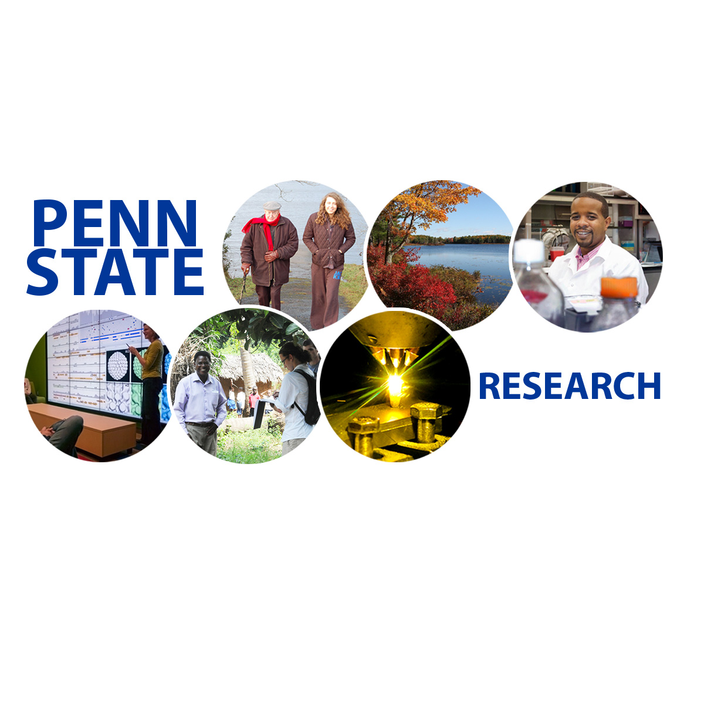

**Neil A. Sharkey, Ph.D.**

**Vice President for Research**

**304 Old Main**

**nas9@psu.edu**

**September 2015 Executive Summary**

# OVERVIEW

TheMISSION ***of the* Office of the Vice President for Research (OVPR)***is to strengthen and enlarge Penn State research by providing advanced scientific resources, an informed and responsive administrative infrastructure, and an environment that facilitates cooperation and communication between and across University campuses, academic units, research institutes and external stakeholders.*

Penn State consistently ranks among the top 20 US academic institutions in research. Annual research expenditures have nearly tripled in the last two decades to total of $848M in 2013. Since its founding in 1855, Penn State has developed well beyond its agricultural roots as Pennsylvania’s land grant institution into a robust research enterprise with unique strengths and areas of excellence.

Today the OVPR boasts six strong and highly competitive interdisciplinary research institutes providing globally recognized leadership across the arts and humanities, cyberscience, energy and the environment, life science, materials, and social sciences*.* But the research and development landscape is changing. Political leaders and the many constituents we serve – most importantly our students – are looking to us for answers. Universities are expected to be and should be more than isolated bastions of discovery.

## VISION

Penn State will advance its position as a world leader in research that impacts the public good. From fundamental discovery to innovative application and sustainable implementation, our research will, more than ever before, have a transformative impact on the Commonwealth of Pennsylvania, the nation and the condition of our planet.

This plan is designed to ensure that Penn State remains one of the world’s greatest research institutions. It is intended to be ***transformative***, molding this great university into an engine that purposely drives positive societal change, technological implementation and economic development for the public good. It is our duty as a land grant university to respond to global events such as climate change, dwindling natural resources and lean economies by moving beyond discovery to translation and implementation – and we are.

It is not by accident that Penn State has developed the research strengths in the key disciplines needed to undertake these challenges. The first five strategic goals of the OVPR align with the pillars identified by the institutional strategic plan. To these we have added a sixth, reflecting the clear need to better translate our cache of bright ideas into the marketplace:

*Goal 1: Advancing Precision Health in Context*

*Goal 2: Stewarding Natural Resources and the Environment*

*Goal 3: Transforming Education and Improving Access*

*Goal 4: Building Our Digital Future*

*Goal 5: Validating and Exploring Our Cultures*

*Goal 6: Invigorating Entrepreneurship, Technology Transfer and Economic Development*

# STRATEGIES

This strategic plan defines **Six Major OVPR Goals** for the next five years **(2014-2019)** informed and guided by **Six Core Values**. Our core values are an integral part of who we are and help define our agenda. The goals of this plan are built upon *actionable* and *measurable* objectives guided by:

* + - * ***Integrity***
      * ***Respect***
      * ***Responsibility***
      * ***Discovery***
      * ***Excellence***
      * ***Community***

# The OVPR plan simultaneously promotes Five Foundational Principles by encouraging research that is:

* ***Sustainable*:** Penn State research is aimed at the pursuit of human health and happiness, environmental quality and economic prosperity for current and future generations.
* ***Global*:** Penn State research is relevant and collaborative, and is conducted and communicated across cultures and countries around the world to form partnerships to address global intellectual challenges and ensure the greatest impact.
* ***Engaged*:** Penn State research is sensitive to and connected with societal need and the context in which it is embedded.
* ***Collaborative*:** Penn State research is performed through extensive internal and external collaborations and partnerships, essential elements of effective research.
* ***Supporting the Land Grant Mission*:** Penn State research that maximally contributes to the good of the people, governments, businesses and organizations of Pennsylvania.

**Supporting Strategies** for these core values and foundational principles include:

* Meeting the Imperatives for Higher Education and Fostering Diversity by inclusion of objectives addressing the Seven Grand Challenges for Diversity
* Improving strategic proposal development and post-award management
* Enhancing services, efficiencies and resources across OVPR units
* Leveraging the Philadelphia Navy Yard for increased partnerships in Southeast PA
* Increasing Penn State's Pittsburgh presence through partnerships with the University of Pittsburgh and Carnegie Mellon University

# OUR GOALS

Penn State is a world leader across many highly visible research domains, ranking 17th nationally among US research institutions. Steady growth of our funding portfolio resulted in $848M in expenditures in FY2013 (Figure 1). This success reflects positive and successful relationships with a broad range of federal, state, foundation and corporate sponsors. To support ***positive societal outcomes***, the OVPR will continue to encourage ***transformative and translational*** ***research*** that impacts society in meaningful ways, while seeking the broadest possible public good. Six goals advance this plan.

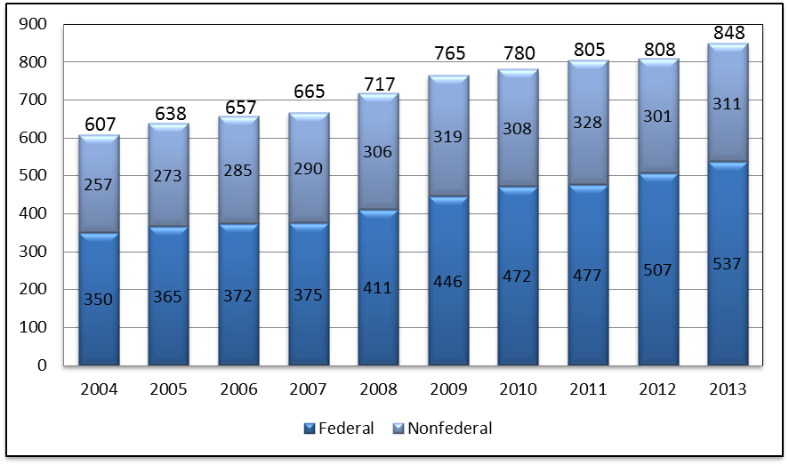

Figure 1. Penn State annual research expenditures from 2004 to 2013.

# 

# GOAL 1: Advancing Precision Health in Context

Penn State OVPR will promote precision healthcare and health resiliency in populations and individuals by melding University research expertise in the life sciences, social and behavioral sciences, medicine, engineering and informatics for translation to clinical practice, service and education.

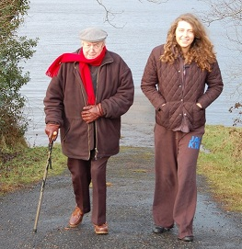

Six specific objectives will converge on a common goal of improving the health and well-being of humans and of society by connecting diverse informed avenues.

### **SIGNATURE OBJECTIVE 1.1** Build expertise in evolutionary medicine and risk management

Penn State is uniquely placed to lead the world in evolutionary risk assessment and management. Not only do we have substantial existing expertise in infectious disease, cancer, evolutionary biology, ecology, insecticide resistance and resistance in plant pathogens, but we have an institute structure that breaks down disciplinary boundaries and builds transdisciplinary research teams. No other institution has had the vision to bring such a diverse group of clinical, life, agricultural and social scientists together.

### **OBJECTIVE 1.2** Establish the Center for Lifespan Fitness, Performance and Health

The Center for Lifespan Fitness, Performance and Health will capitalize on a Penn State culture that recognizes the importance of balance between academics and athletics in our student population, as well as the proven benefits of activity and physical fitness on mental health and well-being across the age spectrum.

### **OBJECTIVE 1.3** Build a deeper understanding of personalized health through integrating individual biological and behavioral data

Penn State expertise spans all domains to address the challenges of the explosion of Big Data to put it to the most beneficial uses for health and societal well-being – from gene expression to behavioral responses – to allow us to address fundamental issues of healthcare through Personalized Medicine.

### **OBJECTIVE 1.4** Apply understanding of bio-psycho-social processes to develop strategies that reduce the adverse effects of environment and lifestyle on human health and well-being

Behaviors such as smoking and poor nutrition are associated with 40% of premature deaths in the US.[1] The OVPR will champion the development and implementation of sustainable practices aimed at reducing the morbidity and mortality through changes in environments and lifestyles.

### **OBJECTIVE 1.5** Reduce social disparities in health and healthcare

Social science translational research will ultimately promote the health and well-being of diverse populations of children, youth and families and aid in the development of evidence-based policies and practices for remediating widening gaps in the health, education and community resources. The ultimate goal is to sustain a diverse and changing population in a global society.

### **OBJECTIVE 1.6** Foster the convergence of biological, engineering, materials and physical science expertise to enable transformational discoveries supporting human health

Convergence – the integration of the biological, engineering and physical sciences – is leading a “third revolution” in the life sciences that follows in the footsteps of molecular biology and genomics. Through broad interdisciplinary collaborations between institutes, Penn State will be a leader in this revolution with a Center for Convergence of Biological, Engineering and Material Sciences (CoBEAM). The integration of these distinctive disciplines and cultures will drive innovation and create entirely new approaches to address some of society’s most pressing problems.

# GOAL 2: Stewarding Natural Resources and the Environment

Penn State will further advance its established leadership in environmental stewardship with specific foci on water, agricultural, energy, climate and human resources.

**

Penn State’s position as a world leader in the stewardship of natural resources and the environment will enable research that focuses on pressing and timely questions of natural resource management, energy and the environment. Advancing this stewardship will include four objectives focused around five unifying research themes: 1) Smart Energy Systems, 2) Future Energy Supply, 3) Heath and Environment, 4) Climate and Ecosystem Change and 5) Water and Biogeochemical Cycles.

### **SIGNATURE OBJECTIVE 2.1** Advance global water security through knowledge about water flows and systems

Water is an essential resource for biological, ecological, industrial, and nearly every other system on Earth. Creation of the ***Penn State Water Institute*** will facilitate better integration of existing resources for real world impacts in the Commonwealth and beyond.

### **OBJECTIVE 2.2** More firmly establish Penn State leadership across all energy domains

As society continues to increase its energy consumption needs, improvements in ***energy sources, efficiency, infrastructure and management*** will become increasingly important to the process of stewarding natural resources. The Department of Energy (DOE) ranks Penn State 9th nationally in energy research, and the Science Citation Index ranked Penn State 2nd in publications and citations. We are positioned to develop and disseminate innovative methods for energy production, infrastructure, utilization, carbon sequestration, energy storage and management, related environmental questions, energy efficiency of buildings, transportation, businesses and other modes of consumption.

### **OBJECTIVE 2.3** Protect and sustain natural systems through research on innovative and effective stewardship of living systems, landscapes and human-environment interactions

To maintain Penn State’s position as a world leader in the stewardship of natural resources, the OVPR will encourage and facilitate research focusing on timely and important questions of natural resource management and environmental stewardship to help humans better protect to the world around them.

### **OBJECTIVE 2.4** Promote sustainability research that simultaneously supports social well-being, economic prosperity and ecological health

Anthropogenic and environmental changes are having a profound impact on the health and sustainability of humans, agriculture and natural ecosystems. The OVPR institutes will work with the Colleges and Penn State’s Sustainability Institute to comprehensively integrate sustainability into the University’s operations, teaching and outreach to prepare students, faculty, staff and members of the wider community to be sustainability leaders across all facets of their lives.

# GOAL 3: Transforming Education and Improving Access

The Penn State OVPR will transform education through research-based opportunities for engaged scholarship and learning.

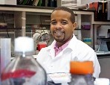

Penn State President Eric Barron has identified six imperatives for successful institutions of higher education:excellence; student engagement; demographics and diversity; student career success and economic development; accessibility; and technology. Research provides essential and integral contributions to meeting these imperatives. It helps us discover how to better achieve these goals and is a best practice for education through the engaged scholarship of students and learners of all types. Thus, four OVPR objectives will drive excellence and advance the educational mission of the institution.

### **SIGNATURE OBJECTIVE 3.1** Promote Engaged Scholarship through research-related experiences involving advanced instrumentation and technologies, and inclusive of minorities, veterans and students at all campuses

Engaged scholarship encompasses a wide variety of out-of-classroom academic learning experiences to complement in-classroom learning and reach a broad spectrum of learners. A robust ***Engaged Research Scholars Program*** will focus on the inclusion of veteran, underrepresented and disadvantaged populations in activities supporting career development.

### **OBJECTIVE** 3.2 Educate faculty, students and staff to actively support technology transfer, research commercialization and work with private sponsors

The competitive global economy is changing the culture of higher education. The need for a highly skilled workforce to support commercialization is now recognized well beyond the business and industry sectors. Penn State’s education mission is not complete until Penn State research is fully translated into beneficial applications supporting societal well-being.

### **OBJECTIVE 3.3** Create a robust postdoctoral development program to pipeline the best faculty talent

Baby boomer retirements are rapidly depleting the population of active senior researchers. To maintain its competitiveness and meet its mission as an educational institution, Penn State must establish a reputation for excellence in training the next cohort of senior scientists. In this development pipeline, postdoctoral researchers are now one of our most valuable assets.

### **OBJECTIVE 3.4** Educate faculty to effectively apply and disseminate research findings beyond traditional academic forums

Penn State must effectively communicate with the public and community we serve. It is our obligate mission as a land grant university and recipient of federal funding for research to fully communicate scholarly findings to all audiences.

# **GOAL 4: Building Our Digital Future**

While we all live and use digital assets from computer to cell phones in our everyday lives, Penn State intends to create and advance the next generation of breakthrough technologies via digital discovery, innovation and extension.

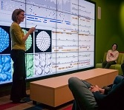

Our ability to gather digital data now outstrips our ability to utilize data. In order to ensure our well-being and economic prosperity, we must gain insights, drive innovation and inform policies by advancing and applying scientifically rigorous approaches for data analysis and computational modeling. Penn State is decisively responding to this challenge with leadership from the ***Institute for CyberScience (ICS)*** todrive digital discovery, innovation, extension and learning to develop the next generation of digital assets to advance our academic priorities.

### **SIGNATURE OBJECTIVE 4.1** Establish Penn State as the global leader in digital discovery and innovation for new insights and their translation to ensure societal well-being and economic prosperity

Penn State embarked on developing capabilities for digital leadership research with the 2011 Report of CyberScience Task Force,[2] and more recent task forces to determine how Advanced CyberInfrastructure (ACI) should be enhanced and reorganized. Investments along these fronts will continue with: 1) bold, coordinated faculty co-hires to build capacity to advance foundations and applications for “Big Data,” “Big Simulations” and “Big Systems,” and 2) an initiative to bring forth computational modeling, simulation and data analysis to support our strengths in theory, experiments and observations.

### **OBJECTIVE 4.2** Establish Penn State as the pioneering leader in Digital Extension for economic development through access to state-of-the-art cyberinfrastructure and personalized learning in research-intensive environments

Penn State is a land-grant university founded around the concept of agricultural extension to develop and deliver technologies and educational programs. To continue this leadership in the current era of cyber enlightenment, we intend to provide leadership in “digital extension” to invigorate the economy – both locally and globally – through entrepreneurship and the launch of startups (Figure 2). Access to our state-of-the-art cyberinfrastructure, technical training and personalized learning in research-intensive environments will support creativity for pathways leading from discovery to product design and prototyping.

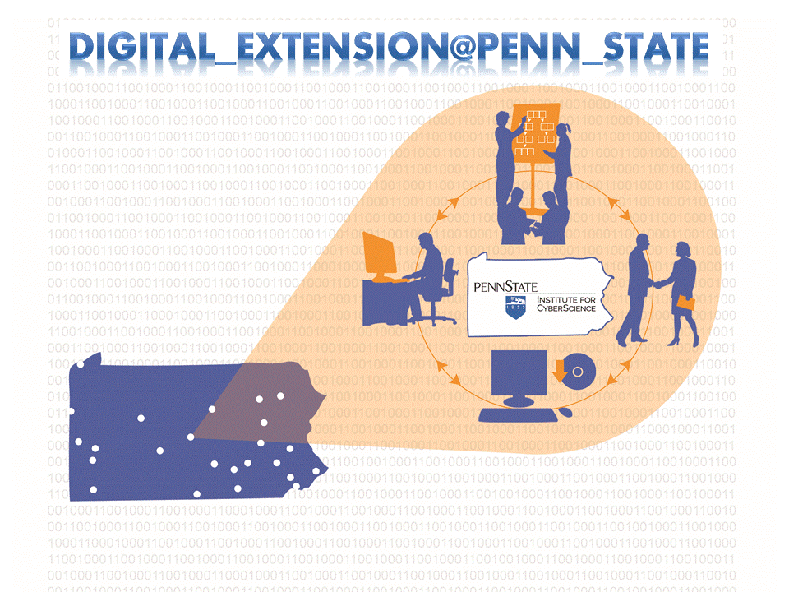

Figure 2: Digital extension is the future of Penn State’s land grant mission.

### **OBJECTIVE 4.3** Establish Penn State as the global digital destination for science and scholarship by developing robust “***science gateways”*** – hubs on the web for advancing interactive, participatory modes of inquiry, learning and outreach

Digital discovery and innovation often leads to the development of scientific software, tools and data collections that can be leveraged by others, and thereby firmly establishes our academic pre-eminence in the digital age. By building cyber “***science gateways***”[3] or hubs on the web that host digital tools and data, we will become the digital destination for participatory modes of inquiry, learning and outreach.

# GOAL 5: Valuing and Exploring our Cultures

The Penn State OVPR will build stronger inter-disciplinary communications and collaborations to foster and disseminate outcomes of research undertaken to enhance understanding and valuation of diverse cultures.

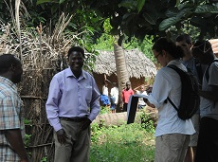

Penn State is a leader in the fields of anthropology, sociology and psychology where researchers are looking at how individuals have come together to form modern societies with diverse cultural beliefs and practices. Engineers and architects design much of the physical and cyber infrastructure supporting our cultures. Faculty in the humanities study the history, variety and significance of human expression since the invention of writing. Faculty in communications and the arts study develop and practice forms of human expression used in the Pyramids to the internet. International research and collaborations advance the understanding of diverse cultures. Given the complexities of human beings, researchers in all these areas have a clear role in valuing and exploring – *and finding solutions benefitting* – our cultures (Figure 3).



Figure 3. A ceramic water filter jointly developed by ceramic scientists, artists and engineers provides potable water in isolated communities (Credit: B. Stephen Carpenter II).

## 

## SIGNATURE OBJECTIVE 5.1 Make integrative arts and humanities research a signature component of the research enterprise at Penn State, thereby establishing our national leadership in this emerging domain

Establishing Penn State as a national and international leader in interdisciplinary arts and humanities research is a fundamental goal during this planning cycle. To this end, the OVPR willmake available additional resources to build on and expand the substantial connections that already have been established across our colleges, institutes and departments. Several developing centers and laboratories will provide additional infrastructure to support this developing initiative, including the *Arts and Design Research Incubator (ADRI)*, *Borland Project Space* and *The Center for Imaging Innovation (CI2).*

## OBJECTIVE 5.2 Remediate gaps in the resources available to vulnerable populations including children, youth, elders and their families, in a global society

Vulnerable populations include minorities, persons with mental and physical disabilities, and those living in poverty. Gaps in the resources supporting vulnerable populations occur in every human service sector from education to medicine to social services. Penn State has a long and growing list of researchers who are expanding knowledge and developing interventions to support the many different vulnerable members of our society including children, elders, the differentially-abled, and the socially and economically disadvantaged. The OVPR will create a platform upon which researchers working in this landscape across colleges and institutes can come together to share knowledge and create synergies.

### **OBJECTIVE** 5.3 Invigorate research and creative accomplishments across the arts and humanities

Since 2010, the *Institute for the Arts and Humanities* (IAH) has taken decisive steps to become more prominent in the international world of humanities centers and institutes. The time is right for additional investments in the Institute to support its efforts to: remain active in the Consortium of Humanities Centers and Institutes projects; participate energetically in Mellon Foundation initiatives; expand the postdoctoral program; expand residencies and grants; leverage “The Boundaries of the Human” project; and bring visiting scholars and artists to campus.

## OBJECTIVE 5.4 Become the institution known for championing international research that develops and applies solutions for societal challenges worldwide

Penn State connects with every continent on the globe through an expansive international research network and student base. These connections remind us of our societal obligation to consider not only the value of specific research productivity for the US and other G20 countries, but to strive to reduce disparities in access to resources and improve the human condition among poorer and more remote societies less like our own. Three major initiatives will stimulate a cross-fertilization of skills and expertise to enable new discoveries and new solutions: 1) An ***international researchers’ network***; 2) new ***interdisciplinary research initiatives*** advanced in collaboration with the Global Engagement Network; and 3) an ***administrative best practices network***.

# GOAL 6: Invigorating Entrepreneurship, Technology Transfer and Economic Development

*Penn State will continue to translate its scientific research and leverage its resources to invigorate entrepreneurship, technology transfer and economic development in Pennsylvania, the United States and the world.*



The newly created ***Office of Industrial Partnerships*** (OIP) will lead advancement of three major objectives to significantly change the culture of Penn State and the way we work with industry.

### **SIGNATURE OBJECTIVE 6.1** Establish Penn State as the "go-to" academic institution for industry-sponsored research by creating a local ecosystem where Penn State researchers work hand-in-hand with industry to accelerate technology transfer

The University will strive to integrate our academic priorities with the priorities of our industry partners by working cooperatively with the Chamber of Business & Industry of Centre County, local partners at the Commonwealth Campuses and partners in Philadelphia and Pittsburgh. Academic scientists, professors of practice, postdoctoral scholars and students at all levels will work alongside personnel employed by our industrial partners to develop new technologies and practices. Company internships for faculty and students will be reciprocated through recruitment and deployment of **professors of practice** who will provide the practical know-how and business experience to effectively guide our participation and prepare students across all Penn State majors.

### **OBJECTIVE 6.2** Create a Penn State culture that values entrepreneurship, technology transfer and economic development

Creating a Penn State culture that values entrepreneurship, technology transfer and economic development means changing how traditional academics think and operate. The OIP will act as a change agent by disseminating information, organizing educational activities and monitoring change. Managing related resources will contribute to our success. This includes marketing existing resources and opportunities with theFund for Innovation, Ben Franklin Technology Partners for Central and Northern Pennsylvania, Innovation Park, Undergraduate Entrepreneurship Minor and student organizations.

### **OBJECTIVE 6.3** Improve, streamline and clarify processes to accelerate the pace at which technologies move from discovery to implementation

Penn State ranks 62nd in technology licensing income, 41st in number of patents filed and 35th in number of patents among academic institutions. These low rankings are an indicator of necessary systemic change. Leadership is now studying the licensing revenue structure of the University to optimize resources and to study other institutional approaches to identify best practices in this domain. Outreach and education activities will be extended collaboratively by the OIP and regional business organizations.

# FRAMEWORK FOR DIVERSITY

Interdisciplinary research is a core thrust of the OVPR. By its very nature, interdisciplinary research promotes teamwork, offers exposure and demands respect for differing perspectives. Consequently, objectives aimed at this mission will simultaneously impact the seven major challenges to diversity at Penn State and support the President’s imperatives for diversity, demographics and accessibility.

| Diversity Challenges | OVPR Objective Number & Area of Impact |
| --- | --- |
| *1: Developing a Shared and Inclusive Understanding of Diversity* | **1.5; 5.2 –** Research on disparities  **5.1** – Interdisciplinary research team collaborations |
| *2: Creating a Welcoming Campus Climate* | **3.3** – A Postdoctoral Development Program recruiting, supporting, training and mentoring diverse populations |
| *3: Recruiting and Retaining a Diverse Student Body* | **3.1** – Engaged scholarship activities involving diverse populations |
| *4: Recruiting and Retaining a Diverse Workforce* | **1.2; 1.3; 2.1; 2.2; 2.3; 2.4;** **5.3; 6.1; 6.2; 6.3** – These objectives involve job creation, hiring and mentoring, and will implement practices to recruit and retain a more diverse workforce |
| *5: Developing a Curriculum That Fosters U.S. and International Cultural Competencies* | **3.1** – Engaged scholarship activities involving diverse populations  **3.3** – A Postdoctoral Development program recruiting, supporting, training and mentoring diverse populations  **3.4** – Training for communications across diverse cultures  **4.2** – Distance education services  **5.4** – International research for solutions to global problems |
| *6: Diversifying University Leadership and Management* | **1.2; 1.3; 2.1; 2.2; 2.3; 2.4** – Increasing diversity will be goal in strategic hires for leadership positions |
| *7: Coordinating Organizational Change to Support Diversity Goals* | OVPR Human Resource staff advancing hiring practices for diversity and OVPR staff participation on equity commissions |

# STRATEGIES and TACTICS

The first draft of the OVPR plan was circulated widely among members of the University Research Council and University leadership between August 2014 and February 2015. Edits were completed to address weaknesses noted in the October 2014 review by the Office of the Planning and Institutional Assessment (OPIA). A roadmap for implementation has now been created to include an OVPR leader who will champion each objective by monitoring progress toward our goals. These individuals will monitor progress using defined metrics. Progress will be documented and assessed every six months and discussed in biannual collaborative planning meetings that will include OVPR leaders.

1. Advancing Precision Health in Context
1.1. Build expertise in evolutionary medicine and risk management. 
1.2. Establish the Center for Lifespan Fitness, Performance and Health.
1.3. Build a deeper understanding of personalized health through integrating individual biological and behavioral data. 
1.4. Apply understanding of bio-psycho-social processes to develop strategies that reduce the adverse effects of lifestyle choices on human health and well-being.
1.5. Reduce social disparities in health and healthcare.
1.6. Foster the convergence of biological, engineering, materials and physical science expertise to enable transformational discoveries supporting human health.
2. Stewarding Natural Resources and the Environment
2.1. Advance global water security through knowledge about water flows and systems.
2.2. More firmly establish Penn State leadership across all energy domains.
2.3. Protect and sustain natural systems through research on innovative and effective stewardship of living systems, landscapes and human-environment interactions.
2.4. Promote sustainability research that simultaneously supports social well-being, economic prosperity and ecological health.
3. Transforming Education and Improving Access
3.1. Promote Engaged Scholarship through research-related experiences involving advanced instrumentation and technologies, and inclusive of minorities, veterans and students at all campuses.
3.2. Educate faculty, students and staff to actively support technology transfer, research commercialization and work with private sponsors.
3.3. Create a robust postdoctoral development program to pipeline the best faculty talent.
3.4. Educate faculty to effectively apply and disseminate research findings beyond traditional academic forums.
4. Building Our Digital Future
4.1. Establish Penn State as the global leader in digital discovery and innovation for new insights and their translation to ensure societal well-being and economic prosperity.
4.2. Establish Penn State as the pioneering leader in Digital Extension for economic development through access to state-of-the-art cyberinfrastructure and personalized learning in research-intensive environments.
4.3. Establish Penn State as the global digital destination for science and scholarship by developing “science gateways” – hubs on the web for advancing interactive participatory modes of inquiry, learning and outreach.  
5. Valuing and Exploring Our Cultures
5.1. Make integrative arts and humanities research a signature component of the research enterprise at Penn State, thereby establishing our national leadership in this emerging domain.
5.2. Remediate gaps in the resources available to vulnerable populations, including children, youth, elders and their families, in a global society.
5.3. Invigorate research and creative accomplishments across the arts and humanities.
5.4. Become the institution known for championing international research that develops and applies solutions for societal challenges worldwide.
6. Invigorating Entrepreneurship, Technology Transfer and Economic Development
6.1. Establish Penn State as the “go-to” academic institution for industry-sponsored research by creating a local ecosystem where Penn State researchers work hand-in-hand with industry to accelerate technology transfer.
6.2. Create a Penn State culture that values entrepreneurship, technology transfer and economic development.
6.3. Improve, streamline and clarify processes to allow for accelerating the pace at which technologies move from discovery to implementation. 

PHOTO 6: Patrick Mansell/Penn State

1. Schroeder, S. A. (2007). We can do better – improving the health of the American people. *The New England Journal of Medicine, 357*, 1221-1228.
2. See Report of the 2011 CyberScience Task Force, the Pennsylvania State University <http://ics.psu.edu/wp-content/uploads/2014/08/ctfreptlores.pdf>
3. See <http://sciencegateways.org/what-is-a-science-gateway/>, 2015.