Unit Strategic Plan: Penn State Beaver
2014/2015 through 2018/2019
A more detailed version of this plan can be found at:
https://beaver.psu.edu/2017-2019-strategic-plan

The World... Right Here
Penn State Beaver’s Revised Strategic Plan 2017-2019

Background
On June 3, 2016, Royal Dutch Shell announced it would construct an ethane cracker plant in Potter Township, just a few miles from the Beaver campus. Just one month later, a new chancellor joined the Penn State Beaver team. The existing 2014-2019 Strategic Plan consisted primarily of a list of nine goals (APPENDIX I) that were reactive to an environment that was sure to change. Given Pennsylvania State University’s status as the only institution ranked in the top five for productivity in every key area of energy research, the time was right to begin a strategic visioning process that would define Penn State Beaver’s position and potential within the Pennsylvania State University, the Pittsburgh region, and the new and increasingly complex environment in Beaver County. Penn State Beaver was searching for its place in the world.
Informed by the intentionality of Pittsburgh’s economic transformation and the Pittsburgh’s Allegheny Conference Inflection Point study, Beaver County leaders are responding to this new environment with a strategic approach to community development through an organizational structure of five councils. Penn State Beaver’s chancellor is a member of the Partnership’s Quality Education Council, for which she chairs the Postsecondary Education Subcommittee; she also serves on the Economic Development Task Force and the Board of the Beaver County Chamber of Commerce. Through these types of outreach, Penn State Beaver’s faculty, staff, and students can participate in the county’s efforts in ways that will benefit both the region and our campus.
Certainly, the most pressing goal of Penn State Beaver is to meet the challenge of maintaining enrollments in a region of declining college-going-aged students, with higher tuition than that of our traditional competitors. We believe that, in addition to contributing to the community and benefiting our students, each of the strategic initiatives in the revised strategic plan will both attract students to our campus who might not formerly have considered Penn State Beaver, and engage all of our students towards completion and later success. For example, the increased emphasis on the Association of American Colleges and Universities’ (AAC&U) High Impact Practices such as internships and global learning will better position the Beaver campus alongside private liberal arts colleges, against whom our tuition compares favorably, and also more powerfully engage students in their studies. We are particularly poised for global learning, given the new chancellor’s background is in German and international education administration, and the fact that almost a third (10 of 32) of our full-time faculty originally hail from outside of the United States. With our focus on industry relations in the context of the global nature of today’s economy, we can guide our students towards fulfilling and successful careers through understanding their place in the world.

Process
As part of the Pennsylvania State University, the Beaver campus began its 2016-2017 Strategic Visioning Process with the organizing principle of Penn State’s new campaign areas: Open Doors, Impact the World, and Transformative Academic Experiences. In doing so, we broadened the scope of Open Doors beyond student scholarships, focusing on welcoming academic spaces, hiring qualified staff, and better promoting our opportunities in order to invite the community more purposefully onto our campus. Each of the subcommittees (APPENDIX III) also took into account the Penn State strategic foundations and priorities as grouped into the three campaign areas (APPENDIX II). Over the course of the year, and as a result of campus-wide conversations, subcommittee members ultimately identified a group of initiatives that were then ranked through a campus-wide survey (APPENDIX IV). The results of that survey, and the grouping of the original nine goals under the new strategic structure, informed the Penn State Beaver revised strategic plan goals (APPENDIX V).

The World… Right Here
As a Commonwealth Campus of a land grant institution, Penn State Beaver has an obligation to contribute to the cultural and economic development of our region, primarily by educating our students for success in the twenty-first century. This mission rose definitively to the top, as community partnerships and industry relations were consistently ranked as high priority across the three subcommittees and through the campus-wide survey. Thus, the overarching strategic priority for the next few years will be to cultivate relationships with local industry (Impact the World) that will 1) inform our academic offerings to meet industry’s needs and provide our students with corporate mentoring and internships (Transformative Academic Experiences), and 2) result in enhanced corporate giving opportunities towards scholarships (Open Doors) and other initiatives. One academic offering local industry and our advisory board members have emphasized is a four-year engineering major.
In addition to the focus on industry relations, a number of other initiatives are identified as priorities. From Open Doors, the need for a comprehensive Campus Master Plan that would begin with a library renovation and include an events pavilion and a park-like amphitheater rose to the top. The Master Plan would also consider such projects as a walking path, social spaces for students, and perhaps soccer fields. Open Doors also reaffirmed the absolute necessity acknowledged in the original strategic plan to build visibility and support in the community, and communicate our presence and opportunities to the region better, through an integrated recruitment and marketing plan. With the understanding that our regional demographics are shifting, this plan would also advance the recruitment of international students, as well as better signage, enhanced transportation, and increased support of opportunities for student-to-student interaction.
The creation of a Beaver County Innovation Hub was recognized as imperative in the Impact the World subcommittee, as a county-wide effort under the Beaver County Chamber of Commerce. Subcommittee members also acknowledged the need for a partnership database that would help us leverage existing relationships and identify gaps. Collaborations with other educational institutions are vital in the twenty-first century environment, therefore the subcommittee prioritized the need both to work better with local schools and to establish and cultivate a Beaver Area Higher Education Consortium, also a priority of the Quality Education Council. Our interactions with the school-aged population should involve guidance towards our degree programs, so that our summer camps should interact better with our academic offerings. Finally, even as we embrace what the anticipated economic development means for our county and our campus, we have the responsibility of working toward sustainability.
The Transformative Academic Experiences subcommittee, which took the AAC&U High Impact Practices as a basis, identified Experiential Digital Global Engagement (EDGE) linked to short-term study abroad programs as an effort that would set the Beaver campus apart as a leader in internationalization in the region. EDGE also complements Penn State’s Digital Innovation efforts, and also supports both the Open Doors priority of recruiting international students and the goal of cultivating a diverse and inclusive environment, as it prepares our domestic students to interact with people who have different backgrounds from themselves. In approaching EDGE as a regional effort across the Penn State Pittsburgh campuses, we are supporting the goal of collaboration with Shenango and the other western campuses, especially towards Penn State Pittsburgh. Most importantly, EDGE can help our students understand their own place in the world. The sense of belonging to the stream of history and having agency within it is often reserved for more privileged populations, but is a foundation for the optimism our students need to strive for success in the twenty-first century. Indeed, within the context of our overarching goal of industry relations and the global reach of industry, we are fulfilling our local Commonwealth Campus mission by connecting our students to global opportunities. At Penn State Beaver, WE ARE… part of the world, and WE ARE… right here.

APPENDIX
I: 2014-2019 Penn State Beaver Strategic Plan 9 goals
II: Penn State Campaign Areas with Strategic Foundations and Priorities
III: Strategic Visioning Committee
IV: 2016-2017 Penn State Beaver Strategic Visioning 21 initiatives (survey results)
V: 2016-2019 Penn State Beaver Revised Strategic Plan 29 initiatives

APPENDIX I: 2014-2019 Penn State Beaver Strategic Plan 9 goals

Goal 1: Strengthen and support a retention-focused campus culture
Goal 2: Develop an integrated recruitment and marketing campaign
Goal 3: Enhance the quality and scope of academic programming
Goal 4: Improve facilities and operations
Goal 5: Strengthen collaborations with Shenango
Goal 6: Create a diverse and inclusive environment
Goal 7: Increase campus visibility and support
Goal 8: Develop compliance programs
Goal 9: Integrate sustainability

APPENDIX II: Penn State Campaign Areas with Strategic Foundations and Priorities

Open Doors
Enabling Access to Education

Impact the World
Driving Economic Development
Ensuring a Sustainable Future/ Stewarding Our Planet’s Resources
Enhancing Health

Transformative Academic Experiences/ Transforming Education
Engaging Our Students
Fostering and Embracing a Diverse World
Enhancing Global Engagement
Advancing the Arts and Humanities
Driving Digital Innovation

APPEDIX III: Strategic Visioning Committee

Steering Committee
John Chapin, professor of communications
Ty Cole, student
Jen Cushman, chancellor (chair)
Roger Davis, provost of Community College of Beaver County
April Johnston, director of public relations
Ashu Kumar, instructor of information science and technology
Jack Manning, president of Beaver County Chamber of Commerce
Carey McDougall, director of academic affairs
Kristen Olson, associate professor of English
Adam Rathbun, director of operations
Carrie Rowe, superintendent of Beaver Area Schools
Alexey Stern, student
Tynetta Tull, student
Open Doors
Amy Deuink
Andy Kirschner
Cassandra Miller-Butterworth
Kristen Olson (co-chair)
Adam Rathbun (co-chair)
Carrie Rowe
Katrina Stanley
Tynetta Tull
Impact the World
Ty Cole
Allison Crouse
Angela Fishman
April Johnston (co-chair)
Ashu Kumar (co-chair)
Jack Manning
Evan McStay
Diana Patterson
Debra Roach
Irene Wolf
Transformative Academic Experiences
John Chapin (co-chair)
Isabelle Cook
Roger Davis
Ted Froats
Carey McDougall (co-chair)
Chris Rizzo
Christina Sheleda
Alexey Stern

APPENDIX IV: 2016-2017 Penn State Beaver Strategic Visioning 21 initiatives (survey results)
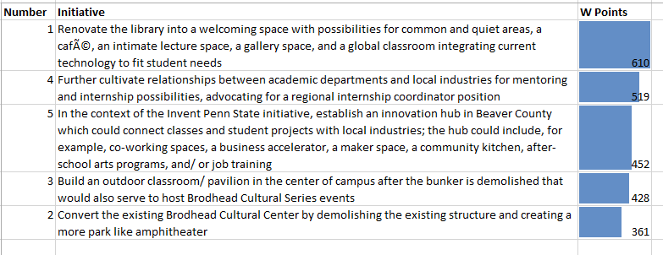
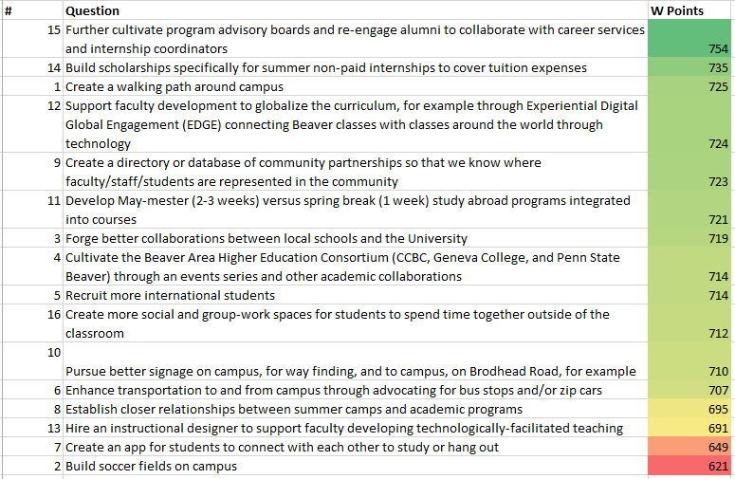

APPEDIX V: 2016-2019 Penn State Beaver Revised Strategic Plan 29 initiatives
(G=2014 strategic plan goal; I=2017 initiative)
Initiative
I INDUSTRY RELATIONS
A Corporate Giving/ Internship Scholarships: I-7 build scholarships specifically for summer non-paid internships to cover tuition expenses
B Community Partnerships/ Innovation Hub: I-3 in the context of the Invent Penn State initiative, establish an innovation hub in Beaver County which could connect classes and student projects with local industries; the hub could include, for example, co-working spaces, a business accelerator, a maker space, a community kitchen, after school arts programs, and/ or jobs training
C Academic/ Industry Relations: I-2 further cultivate relationships between academic programs and industry for corporate mentoring and internships; advocate for a regional internship coordinator position
D Corporate Mentoring and Internships/ Advisory Boards: I-2 further cultivate relationships between academic programs and industry for corporate mentoring and internships; advocate for a regional internship coordinator position; I-6 further cultivate program advisory boards and re-engage alumni to collaborate with career services and internship coordinators
E Regional Internship Coordinator: I-2 further cultivate relationships between academic programs and industry for corporate mentoring and internships; advocate for a regional internship coordinator position
F New Majors: Engineering: G-3 enhance the quality and scope of academic programming/ High Impact Practices; I-2 further cultivate relationships between academic programs and industry
II OPEN DOORS
A Integrated Marketing Campaign: G-2 integrated recruitment and marketing campaigns/ G-7 increase campus visibility and support
- International student recruiting: I-14 recruit more international students
- Signage: I-16 pursue better signage on campus, for way finding, and to campus, on Brodhead road, for example
- Transportation : I-17 enhance transportation to and from campus through advocating for bus stops and/ or zip cars
- Student connection app: I-20 create an app for students to connect with each other to study or hang out
B Campus Master Plan/ Welcoming Academic Spaces
- Library: I-1 renovate the library into a welcoming space with possibilities for common and quiet areas, a café, an intimate lecture space, a gallery space, and a global classroom integrating current technology to fit student needs
- Donna Kuga Events Pavilion: I-4 build an outdoor pavilion in the center of campus after the bunker is demolished that would also serve to host Brodhead Cultural Series events
- Joe Giusti amphitheater: I-5 convert the existing Brodhead Cultural Center by demolishing the existing structure and creating a more parklike amphitheater
- Walking path: I-8 create a walking path around campus
- Social spaces: I-15 create more social and group-work spaces for students to spend time together outside of the classroom
- Soccer fields: I-21 build soccer fields on campus
C Compliance: G-8 develop compliance programs
III IMPACT THE WORLD
A Partnership Database: I-10 create a directory or database of community partnerships so that we know where faculty/ staff/ students are represented in the community
B School Collaborations: I-12 forge better collaborations between local schools and the university
C BAHEC: I-13 cultivate the Beaver Area Higher Education Consortium (CCBC, Geneva College, and Penn State Beaver) through an events series and other academic collaborations
- Educational Ladder: I-13 cultivate the Beaver Area Higher Education Consortium (CCBC, Geneva College, and Penn State Beaver) through an events series and other academic collaborations
- Event series: I-13 cultivate the Beaver Area Higher Education Consortium (CCBC, Geneva College, and Penn State Beaver) through an events series and other academic collaborations
D Summer camps/ academics: I-18 establish closer relationships between summer camps and academic programs
E Sustainability: G-9 integrate sustainability
IV TRANSFORMATIVE ACADEMIC EXPERIENCES
A Retention: G-1 strengthen and support a retention-focused campus culture
B High Impact Practices: G-3 enhance the quality and scope of academic programming/ High Impact Practices
- EDGE/ study abroad: I-9 support faculty development to globalize the curriculum, for example through Experiential Digital Global Engagement (EDGE) connecting Beaver classes with classes around the world through technology; I-11 develop study abroad programs integrated into courses
- (ID INTERNSHIPS)
C Instructional designer: I-19 hire an instructional designer to support faculty developing technologically-facilitated teaching
D Diversity: G-6 cultivate a diverse and inclusive environment
E Shenango and Penn State Pittsburgh: G-5 strengthen collaborations with Shenango

http://greaterpennstate.psu.edu/impact-the-world/
http://www.alleghenyconference.org/PDFs/Misc/InflectionPoint_May2016.pdf
http://thebcpartnership.org/index.php/about-the-partnership/
http://beavercountychamber.com/
https://www.aacu.org/leap/hips
https://www.aacu.org/resources/high-impact-practices
http://strategicplan.psu.edu/foundations/
http://strategicplan.psu.edu/thematic-priorities/

